

UNIVERSITY OF WEST LONDON
SCHOOL OF COMPUTING AND ENGINEERING

Phishing Website Detection using Machine Learning
BSc Dissertation

Mihir Joshi
BSc Computer Science (Hons)
CP6CS46E_A_LONG1_202526
A dissertation submitted in partial fulfilment of the requirements for the award of the Degree of Bachelor of Science in Computer Science of the University of West London

17th May 2026
Supervised by Dr. Omar Al Hashimi

Abstract
Phishing websites continue to be a serious cybersecurity problem because they are designed to look like trusted services and persuade users to enter sensitive information, including login details, banking information, and personal data. Existing defences such as blacklists and rule-based filters can help detect known phishing sites, but they are less effective when attackers create new URLs or change their tactics quickly. This project explores whether machine learning can help identify phishing websites from URL-based evidence and presents the resulting system through an interactive software artefact. The project used a labelled malicious URL dataset, which was processed into a binary classification task containing legitimate and phishing URLs. Each URL was converted into a set of lexical and structural features, including URL length, hostname length, path length, query length, punctuation counts, digit frequency, number of subdomains, IP address usage, suspicious keywords, and URL-shortening indicators. Three supervised learning models were then trained and compared: Logistic Regression, Decision Tree, and Random Forest. Their performance was assessed using accuracy, precision, recall, F1-score, ROC-AUC, confusion matrix analysis, and a manually curated benchmark containing real-world legitimate URLs and phishing-style examples. The Random Forest model produced the strongest overall results, achieving 79.39% accuracy, 76.58% recall, a 52.71% F1-score, and a ROC-AUC score of 0.8698 on the held-out test set. On the separate 50-URL manual benchmark, the system achieved 92.00% accuracy. It correctly identified all phishing-style examples, although it also produced four false positives on legitimate URLs. The final system was deployed as a Streamlit application that allows users to enter a URL and view the predicted class, phishing probability, risk level, and extracted feature values. Overall, the findings suggest that machine learning based on URL features can be useful as an early-stage phishing detection approach, especially for URLs with clearly suspicious patterns. However, the false positives also show the limits of relying only on URL structure. Future improvements could include richer metadata, webpage-content analysis, and broader external validation.

Acknowledgements
I would like to thank my project supervisor, Dr Omar Al Hashimi, for his guidance and feedback throughout this project. His support helped me shape the direction of the work, improve the report, and think more carefully about the design and evaluation of the final artefact. I am also grateful to the academic staff at the University of West London for the teaching and support I have received during my degree. The knowledge I have gained across the course, particularly in programming, data analysis, machine learning, and cybersecurity, has been important in completing this project. Lastly, I would like to thank my family and friends for their encouragement, patience, and support while I worked on this dissertation. Their support helped me stay focused and motivated throughout the development and writing process.

Table of Contents
Abstract i
Acknowledgements ii
List of Figures 10
List of Tables 11
Introduction 1
Chapter Overview 1
Background to Phishing Attacks 1
Historical Context and Evolution 1
The Anatomy of Phishing URLs 2
The Shift Toward Machine Learning 2
Problem Statement 2
The Limitations of Reactive Defence 2
Practical Hurdles in Machine Learning 3
Project Goals and Approach 3
Rationale for the Project 3
Moving Beyond Reactive Security 3
The Case for URL-Based Machine Learning 4
Bridging Theory and Application 4
Research Aim 4
Research Objectives 4
Research Questions 5
Scope of the Project 5
Limitations and Exclusions 6
Structure of the Report 6
Literature Review 7
Introduction 7
Overview of Phishing Website Detection 7
The Challenge of Modern Phishing 7
Detection Methodologies 8
Feature Selection and Practical Trade-offs 8
Conclusion 8
Traditional Detection Methods 8
Blacklisting: The Reactive Standard 9
Heuristic and Rule-Based Filtering 9
Visual and Content Similarity 9
The Shift Toward Adaptive Defence 10
Machine Learning Approaches to Phishing Detection 10
Evolution of Supervised Learning in Security 10
The Trade-off: Performance vs. Transparency 10
Summary 11
URL-Based Feature Engineering 11
The Advantages of a URL-First Approach 11
Categories of URL Features 12
Efficiency and Interpretability 12
Model Interpretability in Cybersecurity 12
Defining Interpretability and Trust 12
The Role of Explainability in Security Operations 13
Human-Centric AI in Cyber Security 13
Project Alignment and Design 13
Common Challenges in Existing Research 14
Data Quality and the Reality of Imbalance 14
Adversarial Tactics and Concept Drift 14
Performance vs. Practicality 15
The Gap in Usability 15
Conclusion 15
Research Gap 15
Performance vs. Interpretability 16
The Need for Practical Evaluation 16
Pushing the Limits of URL-Based Detection 16
Project Contribution 16
Chapter Summary 17
Methodology 18
Introduction 18
Research Philosophy and Approach 18
Philosophical Alignment 18
Experimental Design 18
Beyond Abstract Testing 19
Dataset Selection 19
Data Filtering and Binary Conversion 20
Preprocessing and Data Quality 20
Practical Justification 20
Data preparation and Preprocessing 20
Standardisation and Labelling 21
Data Cleaning and Quality Control 21
Addressing Structural Bias 21
Partitioning for Evaluation 21
Feature Extraction Strategy 22
URL Parsing and Normalisation 22
Feature Categories 23
Design Rationale: Efficiency and Transparency 23
Model Selection 23
Candidate Models 23
Handling Data Imbalance 24
Training and Evaluation Strategy 24
Training Framework and Class Imbalance 24
Performance Metrics 24
Model Persistence and Practical Validation 24
Manual Benchmark Design 25
Benchmark Structure 25
Evaluation and Uncertainty 25
Reporting and Utility 25
Ethical Considerations 26
Responsible Data Use and Safety 26
The Dual-Use Challenge 26
Reliability and the Impact of Errors 26
Transparency as an Ethical Choice 26
Chapter summary 27
System development and Implementation 28
Introduction 28
System Overview 28
System Workflow 28
System Architecture 28
Training and Analysis Layer 29
Prediction and Presentation Layer 29
Shared Utility and Reproducibility Layer 29
Data Ingestion Module 30
Feature Extraction module 30
URL Normalisation and Feature Mapping 30
Shared Model Utilities 30
Model Training Pipeline 31
Prediction Pipeline 31
Evaluation and Reporting Utilities 31
Streamlit Application Design 31
Chapter Summary 33
Results and Analysis 34
Introduction 34
Performance Comparison of Candidate Models 34
Performance Breakdown 35
Key Takeaways 35
Conclusion 36
Selection of the Final Model 36
Balancing Detection and Reliability 36
Robustness and Discriminative Power 36
A Pragmatic Choice 36
Feature Importance Analysis 37
Key Drivers of Prediction 37
Obfuscation and Structural Cues 38
Lower-Impact Features 38
Summary 38
Manual URL Benchmark Results 38
Performance and Accuracy 39
False Positives and Limitations 39
Summary of Findings 39
Error Analysis 40
Streamlit Artefact Demonstration 40
Functional Reliability and Consistency 41
Transparency and Interpretation 41
Designed for Demonstration 41
A Realistic Presentation of Results 41
Summary 41
Discussion of Findings 42
Chapter Summary 42
Discussion and Conclusion 43
Introduction 43
Answering the Research Questions 43
Research Question 1: Model Performance 43
Research Question 2: Model Comparison 43
Research Question 3: Feature Influence 44
Response to the Research Questions 44
Main Contributions of the Project 44
Limitations 45
Future Work 45
Conclusion of the Thesis 46
Appendices 1
Appendix A: Manual URL Benchmark Table 1
Appendix B: Additional Figures and Screenshots 4
Appendix C: Sample CLI Outputs 10
Appendix D: Live URL Prediction Workflow 14
Appendix E: Gantt Chart/Project Plan 15
Bibliography 1

List of Figures

List of Tables

1.0. Introduction
Despite advancements in cyber security, phishing websites continue to be a primary vector for fraud and identity theft by effectively impersonating reputable platforms. This study evaluates the efficacy of machine learning in detecting these threats through URL-based feature extraction. To keep the process lightweight and privacy-conscious, the research bypasses webpage content analysis in favour of structural indicators such as punctuation density, subdomain usage, and the presence of shortening services. This methodology is implemented in a Streamlit-based tool and translates complex URL features into a straightforward risk level and phishing probability for the end user.

1.1. Chapter Overview
This introductory chapter establishes the project’s foundation by examining why phishing continues to bypass traditional security measures and how machine learning offers a more adaptive solution. It defines the core problem and rationale driving this research, alongside the specific objectives and questions I aim to answer. Finally, it outlines the project’s scope and provides a roadmap for the subsequent chapters.

1.2. Background to Phishing Attacks
Phishing remains a dominant threat because it targets the weakest link in the security chain: human judgement. By mimicking trusted brands through deceptive URLs and realistic layouts, attackers trick users into compromising their own data during moments of distraction. In an aera where online banking and e-commerce are the norms, the incentive for identity theft is massive, keeping phishing at the top of the list of practical, effective attack methods.

1.2.1. Historical Context and Evolution
In the early days, phishing attempts were relatively easy to spot – marked by broken English, suspicious formatting, and amateurish website clones. Today, the landscape has shifted. Attackers now deploy sophisticated designs, targeted social engineering, and deceptive URL structures that mirror legitimate services with unsettling accuracy. This constant evolution is exactly why static, rule-based detection often falls short; as soon as a domain is backlisted, attackers simply pivot to new URLs and modified structures, staying one step ahead of traditional filters.

1.2.2. The Anatomy of Phishing URLs
While a single red flag – like an unusually long URL or a misplaced subdomain – might not confirm a phishing attempt, these structural anomalies create a cumulative “fingerprint” that is highly predictive. This project prioritises these URL-based markers because they allow for instantaneous analysis without the overhead of rendering a full webpage. By focusing on these lexical patterns, we can achieve a lightweight detection process that identifies threats in real-time, long before a user even lands on a malicious site.

1.2.3. The Shift Toward Machine Learning
While traditional defences like blacklists and static rules remain a staple of cyber security, they are inherently reactive – only effective against threats that have already been documented. Machine learning shifts this paradigm by moving from “matching” to “predicting”. By training on diverse datasets of both legitimate and malicious URLs, this project examines how models can uncover subtle, non-obvious patterns that manual oversight might miss. The goal is to determine if this automated approach can provide a detection layer that is as interpretable as it is effective.

1.3. Problem Statement
The core challenge of this project lies in the tension between detection speed and accuracy. While blacklists are a standard defence, their reactive nature means they often lag behind the rapid “spin-up, tear-down” lifecycle of modern phishing sites. Conversely, while deep-content inspection or SSL verification can be highly accurate, they introduce significant latency and dependencies on external services. This project explores a middle ground: determining whether we can achieve reliable detection using only the “lexical footprint” of a URL, thereby creating a system that is both fast and entirely self-contained.

1.3.1. The Limitations of Reactive Defence
The primary drawback of reactive defence is the inevitable delay between a site’s launch and its eventual blacklisting. This “window of vulnerability” allows attackers to claim victims before the threat is even documented. While blacklists are still a necessary layer of security, they are fundamentally ill-equipped to handle the surge of short-lived, “zero-hour” phishing URLs. This gap highlights the need for a more predictive model – one that evaluates a URL based on its inherent characteristics rather than waiting for it to appear on a list of known offenders.

1.3.2. Practical Hurdles in Machine Learning
Machine learning is not a silver bullet; its efficacy is strictly tied to the quality and diversity of the underlying training data. Outdated or imbalanced datasets risk creating a model that is either too narrow for real-world application or prone to false positives – misidentifying legitimate sites that happen to share structural traits with malicious ones. To account for this, I have supplemented standard test-set metrics with a manually curated benchmark of real-world URLs, ensuring the system is tested against the nuanced patterns found in the wild rather than just a sanitised dataset.

1.3.3. Project Goals and Approach
This project aims to bridge the gap between machine learning research and practical cyber security application. The workflow involves a rigorous pipeline: processing labelled URL data, engineering lexical features, and evaluating multiple supervised learning algorithms. The ultimate goal is to translate these technical findings into a testable interface. By deploying the final model through Streamlit, the project demonstrates how data-driven insights can be integrated into a lightweight, accessible tool for real-world threat assessment.

1.4. Rationale for the Project
I chose this project because phishing isn’t just a textbook problem – it’s a persistent, evolving threat that requires a more adaptive response than traditional blacklisting. It serves as an ideal case study for applying machine learning to a high-stakes security challenge. I focused specifically on URL-based detection because of its efficiency; it allows for near-instant classification using features that are both easy to extract and highly interpretable. Beyond the technical output, this project provided a hands-on way to refine a full-stack data science workflow, from feature engineering and model evaluation to deploying a functional end-user application.

1.4.1. Moving Beyond Reactive Security
The driving force behind this project is the shift from a reactive to a proactive security posture. Rather than depending on a URL to be flagged and reported after the fact, machine learning allows us to assess risk based on the DNA of the link itself. This isn’t intended to replace traditional defences, but rather to act as a “first-look” assessment – providing an essential layer of security that can flag undocumented threats in real-time.

1.4.2. The Case for URL-Based Machine Learning
Focusing exclusively on the URL ensures the detection process remains lightweight and avoids the overhead of rendering full page content. This methodology also provides a critical safety buffer; by analysing the “lexical fingerprint” of a link without visiting the destination, the system avoids any direct contact with malicious payloads. Furthermore, this approach enhances transparency, as the model’s risk assessment can be directly traced back to tangible indicators like hostname structure, punctuation density, and URL length.

1.4.3. Bridging Theory and Application
The scope of this work extends beyond model optimisation to include the deployment of a viable proof-of-concept. By building a working application, the project translates theoretical machine learning performance into a tangible tool for cyber security practitioners. The resulting Streamlit interface provides a front-end for the model, allowing for live testing and a clear visualisation of risk assessments that would otherwise remain buried in code.

1.5. Research Aim
The study evaluates the effectiveness of URL-based feature extraction in distinguishing phishing attempts from legitimate traffic. By training a machine learning model on these lexical markers, the project seeks to provide a lightweight detection method, ultimately realised in a working software tool that demonstrates the model’s practical utility.

1.6. Research Objectives
To achieve the project’s goal, I have established the following technical milestones:
Investigate the current state of phishing detection with an emphasis on machine learning and URL heuristics.
Assemble and pre-process a high-quality dataset of verified URLs for model training.
Implement an extraction framework to capture critical URL features, such as length, keyword flags, and structural indicators.
Systematically train and compare three key supervised learning models: Logistic Regression, Decision Trees, and Random Forests.
Validate the results using rigorous statistical metrics, including precision-recall analysis and ROC-AUC curves.
Translate the top-performing model into a usable Streamlit application.
Conduct a critical review of the final system to address its limitations and the broader challenges of “zero-day” phishing.

1.7. Research Questions
While the initial proposal explored broader metadata – such as domain age and external site attributes – the final implementation prioritises URL-derived lexical and structural features. This pivot was a strategic choice to ensure the system remains self-contained and high-performing, eliminating dependencies on external APIs or third-party services.
The research is centred on three primary questions:
- Detection Efficacy: To what degree can machine learning accurately distinguish phishing threats using only URL-based features and lightweight metadata?
- Algorithmic Benchmarking: Which architecture-linear, tree-based, or ensemble – strikes the optimal balance between classification accuracy and operational reliability?
- Feature Significance: How do specific structural indicators, such as URL syntax and lexical patterns, impact the system’s overall predictive power and processing speed?

1.8. Scope of the Project
The scope of this study is intentionally narrowed to URL-based machine learning. To maintain a lightweight footprint, the system bypasses resource-heavy methods like full-page scraping, screenshot analysis, or live DNS lookups. By avoiding third-party reputation services, the project focuses exclusively on the “lexical fingerprint” of the URL itself. The workflow encompasses the entire development lifecycle – from data curation and feature engineering to model benchmarking and the final deployment of a functional Streamlit interface.

1.8.1. Limitations and Exclusions
While this system demonstrates the potential of machine learning in threat detection, it is not presented as a production-grade security tool. As with any heuristic-based model, there is a margin for error – specifically regarding false positives and the potential for sophisticated phishing tactics to bypass URL-only analysis. This project should be viewed as a research-focused proof of concept rather than standalone defence mechanism. A more granular breakdown of these performance constraints and their implications can be found in the results and discussion chapters.

1.9. Structure of the Report
This report is organised into six chapters that follow the project’s development from initial research to final deployment:
Chapter 1: Introduction – Establishes the project’s foundation, covering the problem statement, research objectives, and the scope of the study.
Chapter 2: Literature Review – Critically examines the current phishing detection landscape, identifying key research gaps and the evolution of URL-based machine learning.
Chapter 3: Methodology – Details the technical framework, including dataset curation, feature engineering, and the ethical considerations involved in the study.
Chapter 4: Implementation – Documents the build process, from the machine learning pipeline and prediction logic to the final Streamlit interface.
Chapter 5: Results and Analysis – Evaluates model performance and feature importance, supplemented by manual benchmarking and a post-mortem of classification errors.
Chapter 6: Discussion and Conclusion – Reflects on the core research questions, acknowledges the project’s limitations, and suggests directions for future work.

2.0. Literature Review

2.1. Introduction
This chapter explores the current landscape of phishing detection, bridging the gap between established industry practices and academic research. It opens with an analysis of the phishing lifecycle and the inherent difficulties in flagging these sites before moving into a critical evaluation of traditional defences and the transition toward machine learning. I specifically examine the nuances of URL-based feature engineering and the growing demand for model interpretability. Given that phishing continues to bypass conventional filters, research consistently indicates that a “silver bullet” solution remains elusive (Das et al., 2020; Safi and Singh, 2023). The chapter concludes by situating this project within the broader field and defining the specific research gap it aims to fill.

2.2. Overview of Phishing Website Detection
Phishing remains a deceptive cornerstone of cybercrime, designed to trick users into surrendering sensitive assets like credentials or financial data. By mimicking the digital footprint of trusted entities – such as major banks, retailers, and service providers – these sites exploit user trust to bypass traditional security. Recent APWG reports underline the persistence of this threat, noting that attackers are in a state of constant evolution to stay ahead of automated defences (APWG, 2023; APWG, 2025). This reality necessitates a detection strategy that moves beyond simple blacklisting; it must be capable of identifying “zero-day” URLs that haven’t yet been catalogued in global threat databases.

2.2.1. The Challenge of Modern Phishing
The primary challenge in modern phishing detection is the sheer volatility of the threat; malicious sites are often spun up, modified, and dismantled within hours to evade detection. Attackers leverage a sophisticated mix of brand impersonation, deceptive Typosquatting, and obfuscated URL structures to manufacture a sense of legitimacy (Marshal et al., 2016; Sahingoz et al., 2019). As Das et al. (2020) points out, it is critical to evaluate this research through a practical lens – high accuracy scores on static, controlled datasets are often a poor predictor of how a model will handle the messy, unpredictable nature of live traffic.

2.2.2. Detection Methodologies
Current detection strategies range from traditional blacklisting and heuristic rules to more sophisticated visual and content-based analysis. While blacklists remain a reliable defence against established threats, they are inherently reactive and struggle to keep pace with “zero-hour” URLs. Conversely, while inspecting a site’s content or visual layout provides high-fidelity evidence, these methods are resource-heavy and typically require direct interaction with the page (Zhang, Hong, and Cranor, 2007; Medvet, Kirda, and Kruegel, 2008). Machine learning ahs emerged as a way to bridge this gap, offering a more adaptive framework that recognises underlying malicious patterns in labelled data rather than relying on static, easily bypassed rules (Abdelhamid, Ayesh, and Thabtah, 2014; Al Saedi and Flayh, 2023).

2.2.3. Feature Selection and Practical Trade-offs
Feature selection represents a critical bottleneck in phishing detection, directly impacting the balance between classification accuracy and system latency. While incorporating webpage content, domain history, or third-party metadata can sharpen a model's predictive power, these features introduce significant architectural complexity and external dependencies (Jain and Gupta, 2019; El Aassal et al., 2020). Conversely, URL-based features offer a compelling, lightweight alternative; they allow for near-instant extraction without the risks of live site interaction. However, this speed comes with a trade-off, as lexical markers alone may provide a more limited signal compared to multi-modal datasets (Ma et al., 2009; Sahingoz et al., 2019).

2.2.4. Conclusion
Effective phishing detection hinges on a three-way trade-off between precision, computational overhead, and end-user utility. While traditional frameworks still provide a necessary baseline, their rigid nature makes them inherently reactive novel threats. Machine learning presents a more flexible path forward; however, it’s real-world success is not guaranteed. It requires a rigorous alignment of high-fidelity data, thoughtful feature engineering, and evaluation protocols that mirror the unpredictability of live traffic (Hannousse and Yahiouche, 2021; Safi and Singh, 2023).

2.3. Traditional Detection Methods
Conventional phishing defences—ranging from blacklists and rule-based filters to content-scraping and visual auditing—are valued for their transparency and their success in neutralizing established threats. However, these signature-based approaches are fundamentally reactive. As noted by Ma et al. (2009) and Das et al. (2020), they often falter when faced with "zero-hour" URLs, dynamic content obfuscation, or polymorphic tactics designed specifically to circumvent static detection thresholds.

2.3.1. Blacklisting: The Reactive Standard
Blacklisting functions as a signature-based defence, cross-referencing incoming URLs against a database of verified malicious domains. While this provides a high-confidence method for flagging previously reported sites, it is inherently hampered by its reactive nature. As Ma et al. (2009) observed, there is a critical “window of vulnerability” between the launch of a phishing campaign and its eventual inclusion in a blacklist. This detection gap allows attackers to operate with impunity during the early hours of a site’s lifecycle, long before traditional filters are updated.

2.3.2. Heuristic and Rule-Based Filtering
Heuristic systems rely on a set of pre-defined indicators – such as an anomalous URL length, the presence of sensitive keywords, or obfuscated domain structures – to flag potentially malicious activity. Early studies in the field often employed rule-based frameworks and fuzzy data mining to categorise sites based on these markers (Aburrous et al., 2010; Abdelhamid, Ayesh, and Thabtah, 2014). However, the primary drawback of a rigid heuristic approach is its lack of agility; attackers can easily “fuzz” or pivot their URL structures to bypass known rules. Furthermore, these static thresholds are prone to false positives when legitimate, yet complex, URLs inadvertently match a suspicious pattern.

2.3.3. Visual and Content Similarity
Visual and content-driven methodologies focus on the "surface layer" of a site to detect fraud. Early work by Wenyin et al. (2005) and Medvet, Kirda, and Kruegel (2008) pioneered the use of visual similarity—treating brand imitation as a computer vision problem. Similarly, Zhang, Hong, and Cranor (2007) introduced CANTINA, which shifted the focus to the textual "fingerprint" of the page. While these approaches offer high-fidelity evidence of spoofing, they carry significant operational overhead. The requirement to fetch and render live webpage data not only adds latency but also introduces the security risk of interacting directly with malicious infrastructure.

2.3.4. The Shift Toward Adaptive Defence
The inherent constraints of blacklisting, static heuristics, and content-heavy analysis have acted as a catalyst for more adaptive detection frameworks. Machine learning has emerged as a particularly potent tool in this space; its strength lies in its ability to parse complex, non-linear feature combinations that often elude manually defined rues (Al Saedi and Flayh, 2023; Safi and Singh, 2023). This transition does not render traditional defences obsolete but rather underscores why machine learning has become the focal point of contemporary phishing research as we seek more resilient, data-driven security models.

2.4. Machine Learning Approaches to Phishing Detection
Machine learning has become the standard for phishing detection due to its ability to generalize from historical data to identify previously unobserved threats. While the field spans everything from Support Vector Machines to complex deep learning architectures (Sahingoz et al., 2019; Do et al., 2022), this study focuses on a core triad: Logistic Regression, Decision Trees, and Random Forests. This selection was intentional, as it allows for a rigorous comparison between linear, hierarchical, and ensemble-based logic. Furthermore, these models provide a level of transparency that is often lost in "black-box" approaches, ensuring the results remain interpretable and evaluable.

2.4.1. Evolution of Supervised Learning in Security
The availability of labelled datasets makes supervised learning a natural fit for phishing detection. By training on URLs pre-classified as either benign or malicious, models can map the underlying relationships between lexical features and their respective target classes. As demonstrated by Sahingoz et al. (2019) and Bahaghighat et al. (2023), these algorithms can deliver impressive detection rates, provided they are supported by rigorous feature engineering. However, the integrity of the results remains fundamentally tied to the quality of the underlying data and the robustness of the evaluation framework used to validate them.

2.4.2. The Trade-off: Performance vs. Transparency
In machine learning-based security, there is an inherent tension between predictive power and model transparency. While high-dimensional, complex models often yield impressive benchmarks, their lack of interpretability poses a significant challenge in a security context. For an analyst or an end-user, the "why" behind a detection is just as critical as the classification itself (Rudin, 2019; Charmet et al., 2022). Consequently, this project intentionally prioritizes URL-derived features and models that offer clear explanatory value, avoiding the "black-box" nature of more opaque architectures in favour of actionable intelligence.

2.4.3. Summary
Machine learning offers a proactive alternative to traditional defences by identifying malicious patterns that transcend rigid, rule-based logic. Yet, as highlighted by El Aassal et al. (2020) and Hannousse and Yahiouche (2021), the efficacy of these models is not automatic. It depends heavily on the rigor of the underlying methodology—specifically the nuances of dataset curation, the relevance of selected features, and a commitment to evaluation metrics that go beyond simple accuracy to capture real-world reliability.

2.5. URL-Based Feature Engineering
Lexical feature engineering involves distilling a URL into a set of quantitative markers – such as the length of the hostname and path, the density of special characters (dots, hyphens, or digits), and the presence of subdomains or shortening services. This transformation allows a model to detect malicious intent by analysing the “anatomy” of the link. As established by Ma et al. (2009), Le et al. (2018), and Sahingoz et al. (2019), prioritising these URL-level indicators is highly advantageous; it facilitates rapid classification while completely bypassing the latency and security risks associated with fetching live webpage content.

2.5.1. The Advantages of a URL-First Approach
Adopting a URL-first methodology offers significant advantages in terms of execution speed and operational safety. By restricting analysis to the lexical structure of the URL string, the system avoids the inherent risks and computational overhead of interacting with live, malicious infrastructure. This "static-analysis" approach not only simplifies the technical stack but also enhances the reproducibility of results. As noted by Banik and Sarma (2020) and Raja et al. (2021), these lexical markers serve as highly effective predictors when processed through machine learning frameworks, proving that robust classification is possible without the need for high-latency content scraping.

2.5.2. Categories of URL Features
The feature space for URL analysis is typically organized into a four-part taxonomy: length-based, structural, lexical, and binary indicators. Length-based metrics, such as total URL and path character counts, provide initial clues into a link's complexity, while structural markers—including the frequency of dots, slashes, and subdomains—highlight anomalies in the domain hierarchy. These are supplemented by lexical features that scan for brand-impersonation terms and binary flags that identify the use of IP-based hosting or URL shorteners. As noted by Sahingoz et al. (2019) and Shafin (2025), this multi-layered approach is essential because it captures the diverse techniques attackers use to obfuscate their true destination.

2.5.3. Efficiency and Interpretability
The primary appeal of URL-based features lies in their low computational cost and near-instant extraction. Beyond pure efficiency, these markers provide a level of inherent interpretability that complex architectures often lack. Indicators such as anomalous path lengths or excessive character density are far more accessible to human analysts than the high-dimensional, "black-box" features typical of deep learning. This alignment with interpretable machine learning principles is critical in security environments, where the ability to justify a classification is essential for establishing system trust and facilitating rapid incident response (Rudin, 2019; Rjoub et al., 2023).

2.6. Model Interpretability in Cybersecurity
In the cybersecurity domain, interpretability is a prerequisite for effective risk management. Because detection systems directly dictate security posture, the evidence underlying a "phishing" classification must be accessible to the end-user. As championed in Explainable AI (XAI) literature, transparency is a non-negotiable requirement in high-stakes environments like network defence, where the fallout from an incorrect decision—whether a missed threat or a disrupted legitimate workflow—can be severe (Ribeiro, Singh, and Guestrin, 2016; Charmet et al., 2022).

2.6.1. Defining Interpretability and Trust
Interpretability serves as the bridge between a model’s internal logic and human comprehension. Within the context of phishing detection, this necessitates a clear articulation of which specific URL markers drove a “malicious” classification. Systemic trust is rarely a byproduct of high accuracy alone; it is earned when users can critically audit and validate a model’s output. This aligns with Rudin’s (2019) assertion that for high-stakes environments, we should prioritise models that are inherently transparent over “black-box” systems that require secondary, post-hoc explanations.

2.6.2. The Role of Explainability in Security Operations
Explainability serves as a diagnostic tool, providing security analysts with the necessary context to validate a generated alert. In the case of phishing, this involves surfacing the specific lexical markers – such as keyword anomalies, path length irregularities, or excessive subdomain nesting – that triggered the model’s suspicion. This approach aligns with the work of Ribeiro, Singh, and Guestrin (2016) regarding the necessity of per-prediction transparency. Furthermore, as Rjoub et al. (2023) observed, integrating Explainable AI (XAI) is no longer a niche preference but a core requirement for modern cyber security infrastructure.

2.6.3. Human-Centric AI in Cyber Security
A human-centric approach to AI prioritizes the augmentation of human judgment over full automation. This distinction is vital in cybersecurity, where the inevitability of false positives and negatives necessitates a "human-in-the-loop" to verify edge cases. Following the logic of Charmet et al. (2022), explainability serves to bridge the gap between algorithmic output and user trust. This project implements that principle by moving beyond a simple classification; the final application surfaces the raw probability, the assigned risk tier, and the specific lexical features that drove the decision, allowing for a more nuanced, informed response.

2.6.4. Project Alignment and Design
This study prioritizes interpretability by utilizing URL-derived features that translate easily into natural language. Rather than presenting a binary classification in isolation, the Streamlit interface provides a comprehensive breakdown of the decision logic, including the phishing probability, categorical risk level, and specific feature weights. This multi-layered approach addresses the dual requirements of usability and transparency—a balance that Rudin (2019) and Rjoub et al. (2023) identify as essential for the successful integration of machine learning within security research.

2.7. Common Challenges in Existing Research
Contemporary research in phishing detection is often hampered by a set of persistent methodological hurdles. Issues such as uneven class distribution, the volatility of concept drift, and the high cost of false positives continue to complicate the transition from experimental models to production environments. As El Aassal et al. (2020) observe, the effectiveness of these studies must be measured against the harsh realities of practical security operations rather than just isolated metrics. Furthermore, Hannousse and Yahiouche (2021) stress that until the field adopts standardized, high-quality benchmarks, the true progress of machine learning-based detection will remain difficult to quantify.

2.7.1. Data Quality and the Reality of Imbalance
The integrity of a machine learning model is fundamentally limited by the quality of its training data. In the context of phishing detection, issues such as "noisy" labelling, record duplication, and the inclusion of stale examples can severely undermine a model’s ability to generalize to modern threats. This is further complicated by the inherent class imbalance between benign and malicious URLs, which can skew predictive logic. As Hannousse and Yahiouche (2021) point out, the lack of standardized, high-fidelity benchmarks remains a significant hurdle for the field. Consequently, research must shift toward more realistic evaluation frameworks, as emphasised by El Aassal et al. (2020), to ensure that performance metrics translate into real-world efficacy.

2.7.2. Adversarial Tactics and Concept Drift
Phishing detection is a fundamentally "moving target" due to the adaptive nature of adversarial tactics. This evolution results in concept drift, a phenomenon where the predictive patterns extracted from historical datasets gradually lose their relevance as attackers pivot to new methods. By obfuscating traditional keywords, restructuring URL hierarchies, and mimicking legitimate brand formatting with increasing sophistication, threat actors can bypass static filters. As Das et al. (2020) and Do et al. (2022) contend, this continuous behavioural shift remains one of the primary obstacles to maintaining long-term model efficacy in dynamic threat landscapes.

2.7.3. Performance vs. Practicality
There is often a significant disconnect between high-performing research models and their viability in production environments. Architectures that rely on live content scraping, external metadata lookups, or resource-heavy feature extraction introduce substantial latency and fragile third-party dependencies. As established by Ma et al. (2009) and Sahingoz et al. (2019), URL-centric detection offers a more resilient alternative; by isolating the analysis to the lexical properties of the string, systems can achieve near-instantaneous classification without the overhead of a full webpage render.

2.7.4. The Gap in Usability
A recurring limitation in phishing detection research is the prioritization of raw model accuracy at the expense of user-facing delivery. Models that exist solely as notebook prototypes or command-line scripts often fail to bridge the gap between technical validation and practical application. As emphasized by Charmet et al. (2022) and Rjoub et al. (2023), the efficacy of a security system is deeply tied to its communication; users require more than just a prediction—they need intuitive interfaces that articulate the "why" behind an alert through clear, evidentiary support.

2.7.5. Conclusion
Current literature suggests that effective phishing detection extends far beyond the mechanics of a binary classification. It is a multi-dimensional challenge that must account for dataset integrity, the adaptive nature of adversarial tactics, and the broader necessity for transparency and user trust. This project is structured specifically to address these complexities; by integrating rigorous model comparison with interpretable lexical features and manual validation, the final Streamlit deployment serves as an evidence-based response to the operational gaps identified by El Aassal et al. (2020) and Safi and Singh (2023).

2.8. Research Gap
This project addresses a critical void in the literature: the lack of phishing detection tools that balance high-speed performance with human-readable logic. While current research has achieved impressive accuracy through machine learning, there remains a significant disconnect between theoretical performance and operational utility. By focusing on a URL-centric methodology and moving beyond isolated test-set metrics, this study answers the calls from El Aassal et al. (2020), Hannousse and Yahiouche (2021), and Shafin (2025) for more rigorous benchmarking and a shift toward transparent, usability-driven security architecture.

2.8.1. Performance vs. Interpretability
A persistent tension in phishing detection research is the trade-off between predictive ceiling and model transparency. While deep learning architectures and ensemble methods often set the benchmark for accuracy, their "black-box" nature complicates the audit process compared to more granular, feature-based methodologies (Do et al., 2022; Yang et al., 2021). This project navigates that compromise by benchmarking complex models against more interpretable alternatives, all while anchoring the analysis in observable URL-derived features that remain accessible to human scrutiny.

2.8.2. The Need for Practical Evaluation
While standard train-test splits provide a baseline for model performance, they often fail to capture the nuances of live network environments. High accuracy on a curated dataset does not necessarily translate to reliability, as models frequently struggle with "zero-day" phishing tactics or trigger excessive false positives when encountering complex, legitimate domains. This project adopts the perspective of El Aassal et al. (2020), who contend that detection research must be validated against actual security requirements. To meet this standard, I have introduced a dedicated manual benchmark to stress-test the model beyond the limitations of its training data.

2.8.3. Pushing the Limits of URL-Based Detection
While URL-centric detection is prized for its low latency and minimal resource footprint, it is not without its inherent constraints. The primary challenge lies in the overlap between legitimate and malicious string structures: many phishing links are deceptively simple, whereas benign URLs often exhibit a high degree of lexical complexity. As established by Banik and Sarma (2020), Raja et al. (2021), and Sahingoz et al. (2019), while lexical features provide a robust first line of defence, they should be viewed as a high-speed component of a broader strategy rather than a total substitute for deep-content analysis or external metadata.

2.8.4. Project Contribution
This project contributes a comprehensive, end-to-end phishing detection workflow centred on the utility of URL-derived features. The methodology encompasses the entire development lifecycle—from rigorous data curation and feature engineering to a multi-model comparative analysis and a detailed audit of feature importance. By supplementing these results with manual benchmarking and a functional Streamlit deployment, the project provides a tangible solution to the operational gaps highlighted by Safi and Singh (2023) and Safin (2025). This holistic approach ensures that the system is not only technically sound but also meets the standards for explainability and real-world usability.

2.9. Chapter Summary
This chapter has synthesised the evolving landscape of phishing detection, tracing the shift from conventional blacklisting and rule-based filters to sophisticated machine learning frameworks. By evaluating the trade-offs between content-heavy analysis and lightweight URL-based feature engineering, the review has identified the critical dependencies that dictate a model's success—specifically data integrity, feature relevance, and the rigor of the evaluation process. As established by Das et al. (2020), El Aassal et al. (2020), and Safi and Singh (2023), these variables are the primary drivers of operational efficacy and serve as the theoretical cornerstone for the methodology detailed in the following chapter.

3.0. Methodology

3.1. Introduction
This chapter outlines the methodological framework used to develop and validate the phishing detection system. Adopting an experimental machine learning design, the study progressed from the curation of a labelled URL dataset to the engineering of structured features and the benchmarking of various supervised learners. To ensure a robust assessment, the models were subjected to a dual evaluation process: traditional performance metrics were supplemented by a manual benchmark to gauge real-world resilience. This rigorous structure addresses the critical dependencies—data integrity, feature relevance, and realistic validation—identified by El Aassal et al. (2020) and Hannousse and Yahiouche (2021) as essential for credible security research.

3.2. Research Philosophy and Approach
This project adopts an applied experimental methodology, prioritizing the development of a functional artifact over purely theoretical discourse. This approach aligns with the core tenets of cybersecurity research, where the utility of a proposed solution is measured by its empirical performance rather than its conceptual design alone. By subjecting the system to both structured datasets and live examples, the work adheres to the evaluative standards advocated by Das et al. (2020), ensuring that the resulting model is grounded in practical efficacy.

3.2.1. Philosophical Alignment
This project is rooted in a pragmatic research philosophy, prioritizing the resolution of a tangible security challenge: the detection of phishing sites via machine learning. Rather than attempting to position machine learning as a flawless solution, the study seeks to determine the operational viability of a URL-centric approach. By balancing raw detection performance with a focus on user-facing delivery, the research explores how these models can be successfully transitioned from experimental results into a functional, accessible application.

3.2.2. Experimental Design
The experimental framework was built around a structured supervised learning pipeline, beginning with data curation and extending through feature engineering and comparative model benchmarking. This systematic approach—culminating in the selection of an optimal classifier—aligns with the established conventions in phishing research. By training and validating models against high-fidelity datasets of confirmed benign and malicious URLs, the project adheres to the rigorous evaluative standards advocated by Sahingoz et al. (2019) and Al Saedi and Flayh (2023).

3.2.3. Beyond Abstract Testing
To bridge the gap between algorithmic validation and operational utility, this project integrated a manual benchmark alongside a functional Streamlit deployment. This secondary validation layer is essential; standard test-set metrics often fail to capture a model's nuances when confronted with "in-the-wild" phishing tactics or high-fidelity legitimate clones. By subjecting the system to this additional scrutiny, the study directly addresses the argument made by El Aassal et al. (2020) that phishing detection must be evaluated through the lens of practical security requirements rather than isolated statistical performance.

3.3. Dataset Selection
The empirical foundation for this study is the Malicious URLs Dataset (Siddhartha, n.d.), a comprehensive Kaggle-hosted repository comprising labelled entries across four distinct categories: benign, phishing, malware, and defacement. This source was prioritized due to its substantial scale; with 651,191 unique records, it offers the statistical depth necessary to train robust supervised learning models and conduct high-confidence performance testing. Using a dataset of this magnitude ensures that the resulting classifiers are exposed to a wide enough variance of URL structures to achieve meaningful generalization.

Class | Number of URLs | Description
Benign | 428,103 | Legitimate URLs used as safe examples
Defacement | 96,457 | Malicious URLs linked to website defacement
Phishing | 94,111 | Malicious URLs linked to phishing activity
Malware | 32,520 | Malicious URLs linked to malware activity
Total | 651,191 | Total URLs in the original dataset

3.3.1. Data Filtering and Binary Conversion
To align the data with the project’s specific scope, the original multi-class dataset was refactored into a binary classification format. This involved isolating benign entries as the "legitimate" class and phishing entries as the "malicious" target. Malware and defacement records were systematically excluded, as the objective was to develop a specialized detector for fraudulent websites rather than a general-purpose malicious link filter. This targeted pruning resulted in a refined dataset optimized strictly for phishing identification.

3.3.2. Preprocessing and Data Quality
To ensure the integrity of the feature extraction phase, I implemented a rigorous preprocessing pipeline aimed at eliminating noise and standardizing the raw URL strings. This involved a comprehensive data-cleaning process to normalize labels and prune invalid or structurally unsuitable entries. As Hannousse and Yahiouche (2021) observe, the reliability of a machine learning model is directly contingent upon the quality of its input; by addressing these inconsistencies early, the project mitigates the risk of biased performance metrics and ensures that the resulting evaluation reflects genuine predictive power.

3.3.3. Practical Justification
This dataset was selected primarily for its alignment with the project’s focus on lightweight, reproducible detection; it allowed for robust model training and feature extraction without the latency or security risks of live web scraping. While this static approach ensures a controlled experimental environment, it does introduce a temporal limitation. Because phishing tactics are constantly evolving, the resulting model should be viewed as a point-in-time solution that would require periodic retraining to remain effective against emerging threats.

3.4. Data preparation and Preprocessing
The data preparation phase transformed the raw records into a machine-learning-ready format through a pipeline of filtering, binary label mapping, and string cleaning. By standardizing feature extraction and establishing a consistent train-test split, I ensured that every model operated on an identical foundation. This uniformity was critical for maintaining a level playing field during the comparative evaluation stage.

Class | Number of URLs | Percentage | Description
Legitimate | 428,080 | 82.00% | Benign URLs retained as legitimate examples
Phishing | 94,092 | 18.00% | Phishing URLs retained as malicious examples
Total | 522,172 | 100.0% | Final dataset used for binary classification
Table 3.2: Processed binary dataset class distribution

3.4.1. Standardisation and Labelling
By standardising the labels into "legitimate" and "phishing" classes, I framed the problem as a binary classification task. This structure mirrors the real-world decision-making process—identifying a link as either safe or suspicious—and follows the established methodology of Sahingoz et al. (2019). This clarity ensures the models are optimized for the practical requirements of threat detection.

3.4.2. Data Cleaning and Quality Control
To prevent the models from identifying misleading patterns or "noise," I prioritized data hygiene by pruning missing values, malformed URLs, and inconsistent labels. As noted by El Aassal et al. (2020) and Hannousse and Yahiouche (2021), rigorous preprocessing is vital; it ensures that the resulting classifiers are built on realistic examples rather than artifacts of a low-quality dataset. This stage was essential for establishing a reliable foundation for the feature extraction process.

3.4.3. Addressing Structural Bias
Since legitimate URLs significantly outnumbered phishing examples, I addressed this typical imbalance by applying class weights during training. This adjustment ensured the models didn't simply default to the majority class, forcing them to prioritize and learn from the rarer phishing instances. This approach maintains a more realistic detection profile without sacrificing the integrity of the original data.

3.4.4. Partitioning for Evaluation
To ensure a rigorous assessment of generalization, the dataset was partitioned into distinct training and testing subsets. By evaluating each candidate model against the same held-out data, I was able to benchmark their performance on unseen examples under identical conditions. This consistent framework provided the objective basis needed to identify the most resilient classifier during the selection process.

3.5. Feature Extraction Strategy
This project prioritised a feature extraction strategy centred on the lexical and structural properties of URLs. By analyzing measurable attributes directly from the URL string itself—rather than relying on webpage content or external domain lookups—the system maintains high efficiency. This approach is a cornerstone of modern phishing detection; malicious links frequently exhibit distinct patterns designed for deception, obfuscation, or brand impersonation (Ma et al., 2009; Le, Hoang and Nguyen, 2018; Sahingoz et al., 2019).

Feature Category | Features Included | Purpose
Length-based features | URL length, hostname length, path length, query length | Measures URL complexity; identifies outlier lengths typical of malicious redirects
Punctuation-based features | Number of dots, hyphens, underscores, slashes, question marks, equals signs, at symbols, percent signs | Highlights structural anomalies or punctuation stuffing used to hide the true destination
Character-count features | Number of digits, number of special characters | Flags high densities of numbers and symbols often found in automatically generated phishing links
Hostname structure features | Number of subdomains, IP address presence | Detects use of direct IP hosting or deceptive subdomains designed to mimic legitimate brands
Keyword and service indicators | Suspicious keyword presence, shortening-service indicator | Screens for high-risk terminology and the use of URL shorteners to mask suspicious domains
Table 3.3: URL feature Categories used for model training

3.5.1. URL Parsing and Normalisation
To ensure analysis remained consistent, every URL was parsed and normalized into its core components—specifically the hostname, path, and query string. This preprocessing step was vital for handling variations in user input, ensuring the model received a uniform feature set regardless of minor formatting differences in the original URL structure.

3.5.2. Feature Categories
The engineered feature set focuses on specific lexical and structural markers, including segment lengths (URL, hostname, path, and query), character counts (dots, hyphens, digits, and special symbols), and the depth of subdomains. It also flags the presence of IP addresses, shortening services, and suspicious keywords. These metrics were selected based on established research—such as work by Banik and Sarma (2020), Raja et al. (2021), and Shafin (2025)—which demonstrates that such URL characteristics are reliable indicators for identifying phishing and malicious activity.

3.5.3. Design Rationale: Efficiency and Transparency
A URL-based feature set was prioritised for its efficiency, reproducibility, and clarity compared to content-heavy alternatives. By eliminating the need to visit potentially malicious sites or rely on external APIs, the system ensures that predictions are both faster and more secure. Furthermore, because these features correspond to visible URL attributes, this approach aligns with the project’s emphasis on transparency and interpretability (Rudin, 2019; Rjoub et al., 2023).

3.6. Model Selection
To evaluate various learning methodologies, the project utilised three supervised models: Logistic Regression, Decision Trees, and Random Forest. This selection provided a direct comparison between linear, single-tree, and ensemble-based architectures, making it possible to identify which specific framework offered the most effective balance of predictive power, reliability, and transparency.

3.6.1. Candidate Models
Logistic Regression served as a baseline due to its computational efficiency and straightforward interpretability. To capture more complex, non-linear patterns, a Decision Tree was included for its ability to map decision logic clearly. Finally, Random Forest was utilized as an ensemble approach; by aggregating multiple trees, it typically achieves higher accuracy and better generalizes to new data by mitigating the overfitting risks inherent in single-tree models (Sahingoz et al., 2019; Yang et al., 2021).

3.6.2. Handling Data Imbalance
To address class imbalance, class weighting was applied during training to prevent the models from developing a bias toward legitimate URLs, which were more prevalent in the dataset. This adjustment was crucial given the stakes of phishing detection; failing to catch a malicious site is generally more damaging than a false positive on a benign one. By weighting the classes, the model was forced to treat phishing instances with higher priority, ensuring a more robust and risk-aware classification.

3.7. Training and Evaluation Strategy
To ensure a fair comparison, every candidate model was trained on the identical dataset and feature set before being validated against held-out test data. Rather than relying solely on accuracy—which can be a deceptive metric in the presence of class imbalance—a broader suite of evaluation metrics was employed to provide a more nuanced and accurate picture of model performance (El Aassal et al., 2020).

3.7.1. Training Framework and Class Imbalance
The models were trained through a uniform pipeline that utilised class weighting to mitigate the impact of the imbalanced dataset. This approach prevented the models from defaulting to majority-class predictions, instead incentivizing them to prioritize the identification of actual phishing patterns.

3.7.2. Performance Metrics
Model performance was assessed using a comprehensive suite of metrics, including accuracy, precision, recall, F1-score, ROC-AUC, and confusion matrix analysis. While accuracy provided a general view of correctness, precision and recall offered deeper insights into the system's reliability: precision tracked the validity of phishing flags, while recall measured the model's success rate in capturing all malicious URLs. The F1-score served to balance these two, while ROC-AUC evaluated how effectively the model distinguished between classes across varying decision thresholds.

3.7.3. Model Persistence and Practical Validation
Once training was complete, the top-performing model was serialized and saved for integration into the Streamlit application. This ensured the final tool could deliver consistent, real-time predictions without the overhead of retraining. To verify its effectiveness in a real-world context, the model underwent practical validation through manual URL testing and interactive application demonstrations.

3.8. Manual Benchmark Design
To validate the system beyond the constraints of the original held-out dataset, a manual benchmark was established using a combination of live legitimate URLs and active phishing examples. This step was essential because standard dataset metrics can sometimes mask real-world performance gaps; direct benchmark testing provides a more practical look at the model's operational strengths and weaknesses (El Aassal et al., 2020; Hannousse and Yahiouche, 2021).

3.8.1. Benchmark Structure
The manual benchmark consisted of 50 URLs, split evenly between 25 legitimate entries and 25 phishing-style examples. While the legitimate set was comprised of well-known, high-traffic websites, the suspicious entries were selected to reflect common deceptive patterns. This balanced sample provided a clear, manageable framework for testing the model's logic against easily verifiable real-world cases.

3.8.2. Evaluation and Uncertainty
The benchmark analysis involved comparing the model's classifications against their known labels, with a specific focus on borderline cases. By examining instances where the probability sat near the decision threshold, it was possible to gauge the model's confidence levels. This approach moved beyond a simple "correct or incorrect" binary, providing deeper insight into where the system was decisive and where it showed signs of uncertainty.

3.8.3. Reporting and Utility
The benchmark findings were documented through a detailed breakdown of overall accuracy, category-specific success rates, and the frequency of false positives and negatives. By also highlighting borderline predictions, the manual test provided a concrete basis for discussing the system's reliability in practice. Ultimately, this helped validate the Streamlit tool by demonstrating the model's behaviour when confronted with novel examples outside the original training data.

3.9. Ethical Considerations
Ethical considerations were a priority, particularly as phishing detection is a cybersecurity topic with potential dual-use implications. This project was developed strictly for defensive and educational use; at no point did it involve harvesting personal data, targeting individuals, or deploying actual phishing sites. Instead, the scope was confined to detecting suspicious URLs and evaluating the effectiveness of a protective tool.

3.9.1. Responsible Data Use and Safety
To maintain a high safety standard, the project utilised an existing public dataset instead of harvesting sensitive user information. The system’s URL-based design further minimised risk by eliminating the need to visit live, potentially malicious webpages during the prediction process. This approach ensured the project remained secure and practical for demonstration purposes.

3.9.2. The Dual-Use Challenge
Given that cyber security tools can be double-edged, this project was intentionally framed as a defensive resource. The resulting tool aims to bolster user awareness and detection capabilities rather than provide any utility to attackers. This focus on responsible design reflects current research in cyber security and explainable AI, which emphasises the need for accountability when automated systems influence critical security decisions (Charmet et al., 2022L Rjoub et al., 2023).

3.9.3. Reliability and the Impact of Errors
Misclassifications in this context carry real-world weight: a false negative might grant a phishing link undue trust, while a false positive could pointlessly block a safe site. To account for this, the system was assessed through a variety of performance metrics and is positioned as a decision-support tool rather than an absolute authority. Recognising this boundary is a necessary reality for any practical phishing detection framework.

3.9.4. Transparency as an Ethical Choice
Transparency was integrated as a core ethical design principle. By displaying prediction probabilities, risk levels, and specific URL features, the final application allows users to look “under the hood” of each result. This visibility discourages blind reliance on the model and enables a more informed, critical interpretation of the output (Ribeiro, Singh and Guestrin, 2016; Rudin, 2019).

3.10. Chapter summary
This chapter detailed the methodology adopted for the project, covering everything from the experimental design and dataset selection to preprocessing, feature extraction, and model training. It also outlined the criteria for evaluation, the manual benchmark framework, and the ethical safeguards integrated into the process. Overall, the methodology was structured to ensure the system remains lightweight and reproducible, balancing rigorous machine learning metrics with practical, hands-on testing to ensure the results are both accurate and interpretable.

4.0. System development and Implementation

4.1. Introduction
This chapter outlines the development and implementation of the phishing detection system. Built as a Python-based machine learning pipeline with a Streamlit interface, the tool covers the full lifecycle from data preparation and feature extraction to predictive reporting.
To ensure maintainability and ease of testing, the system follows a modular architecture. By decoupling core tasks—such as data ingestion, model training, and visualisation—into distinct components, the workflow remains transparent and scalable. Beyond mere classification, the final application prioritizes user transparency by displaying the predicted label alongside phishing probabilities, risk assessments, and the specific feature values driving the result.

4.2. System Overview
By bypassing heavy webpage content and external lookups in favour of direct URL-derived features, this system functions as a lightweight, highly reproducible detection tool. When a user submits a URL, the application normalizes the string, extracts numerical features, and processes them through a Random Forest model. The Streamlit interface then delivers a near-instant classification, displaying the phishing probability, risk level, and the specific feature data used to reach the verdict.

4.2.1. System Workflow
The workflow starts by filtering a malicious URL dataset into a binary set of legitimate and phishing samples, which are then converted into structured features. After training and comparing Logistic Regression, Decision Tree, and Random Forest models, the Random Forest classifier was selected and saved for the final application. This pipeline bridges the gap between experimental machine learning and a functional, user-facing tool for live prediction.

4.3. System Architecture
The system architecture uses a three-tier design—comprising training/analysis, prediction/presentation, and shared utility layers—to decouple the experimental machine learning workflow from the user-facing application. This modular approach ensures a clear separation of concerns while maintaining technical consistency across the entire project.
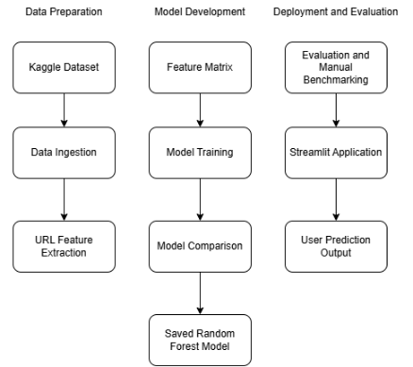
Figure 4.1: System architecture of phishing detection artefact

4.3.1. Training and Analysis Layer
The training and analysis layer manages the entire backend pipeline, including data preparation, feature extraction, and model benchmarking. This layer generated the core evidence for the results chapter, specifically the model performance comparisons, feature importance rankings, and confusion matrices.

4.3.2. Prediction and Presentation Layer
The prediction and presentation layer, centred on the Streamlit application, transforms the trained Random Forest model into a functional tool. By applying the same feature extraction logic used during training, the app processes user-submitted URLs to provide real-time, interactive classifications.

4.3.3. Shared Utility and Reproducibility Layer
The shared utility layer centralizes core functions—such as URL normalization, model loading, and risk scoring—to maintain logic consistency across the training, benchmarking, and deployment phases. To ensure full reproducibility, all processed datasets, models, and visual reports are archived within a structured directory system.

4.4. Data Ingestion Module
The data ingestion module prepares the malicious URL dataset for binary classification by mapping benign and phishing entries to their respective classes while stripping out irrelevant categories like malware or defacement. This stage also covers data cleaning and label standardization to ensure the URLs are ready for feature extraction. Decoupling ingestion from the training pipeline clarifies the workflow and ensures the processed data remains consistent across all subsequent stages.

4.5. Feature Extraction module
By mapping URLs to numerical values, the feature extraction module enables the system to operate without the overhead of webpage analysis, screenshots, or DNS lookups. Relying exclusively on lexical and structural patterns ensures the tool remains lightweight and fast, providing a reproducible framework for near-instant classification.

4.5.1. URL Normalisation and Feature Mapping
Prior to extraction, URLs were normalized and parsed into their primary components—hostname, path, and query string—to ensure consistent handling regardless of whether a protocol like https:// was provided. The resulting feature set tracks attributes such as segment lengths, punctuation and digit counts, subdomain depth, and the presence of IP addresses, shortening services, or suspicious keywords. These metrics were chosen specifically to flag structural and lexical red flags common in phishing, such as convoluted hostnames or misleading paths. Maintaining this exact extraction logic across training, benchmarking, and live deployment was critical to ensure the model received data in the specific format it was trained to interpret.

4.6. Shared Model Utilities
Shared model utilities were developed to centralize core tasks like data loading, URL normalization, and risk assessment, effectively eliminating code duplication. By housing the prediction logic in a single location, the project maintains strict consistency between the command-line scripts and the Streamlit interface. This modularity simplifies maintenance and ensures that testing, benchmarking, and live deployment all rely on the exact same processing and model logic.

4.7. Model Training Pipeline
The training pipeline compared three distinct approaches—Logistic Regression, Decision Trees, and Random Forest—to evaluate how linear, single-tree, and ensemble models performed on the URL feature set. After converting the data into a feature matrix and target labels, the dataset was split into training and testing sets to validate performance on unseen data.
Following a uniform evaluation process, the Random Forest model was selected for final deployment due to its superior accuracy. Both the model itself and its performance metrics were archived to support the results analysis and power the Streamlit application's backend.

4.8. Prediction Pipeline
The prediction pipeline replicates the training workflow to classify new URLs: it normalizes the input, extracts the necessary features, and processes them through the saved Random Forest model. Normalization ensures the system handles varied input formats consistently, while strict feature ordering maintains alignment with the model's training requirements.
Beyond generating a raw classification and probability score, the pipeline converts these outputs into a readable risk level. This logic is shared across both the command-line tools and the Streamlit interface, ensuring uniform behaviour regardless of how the system is accessed.

4.9. Evaluation and Reporting Utilities
Evaluation and reporting utilities provided the empirical foundation for Chapter 5, generating classification reports, confusion matrices, ROC-AUC metrics, and feature importance rankings. To move beyond raw data, the project produced visual aids—including ROC curves and performance charts—to better illustrate model behaviour. Additionally, a manual benchmark of 50 curated URLs offered practical evidence of the model’s real-world efficacy, bridging the gap between statistical metrics and functional testing.

4.10. Streamlit Application Design
The final artefact was developed using Streamlit, transforming the Python-based machine learning project into an interactive web application without the overhead of a traditional web framework. Designed as both a functional detection tool and a project showcase, the interface allows users to input URLs and view real-time classifications alongside risk levels, phishing probabilities, and specific feature data. To provide transparency, the app also presents broader context, including model snapshots, performance comparisons, and feature importance rankings, illustrating exactly how the underlying model behaves.

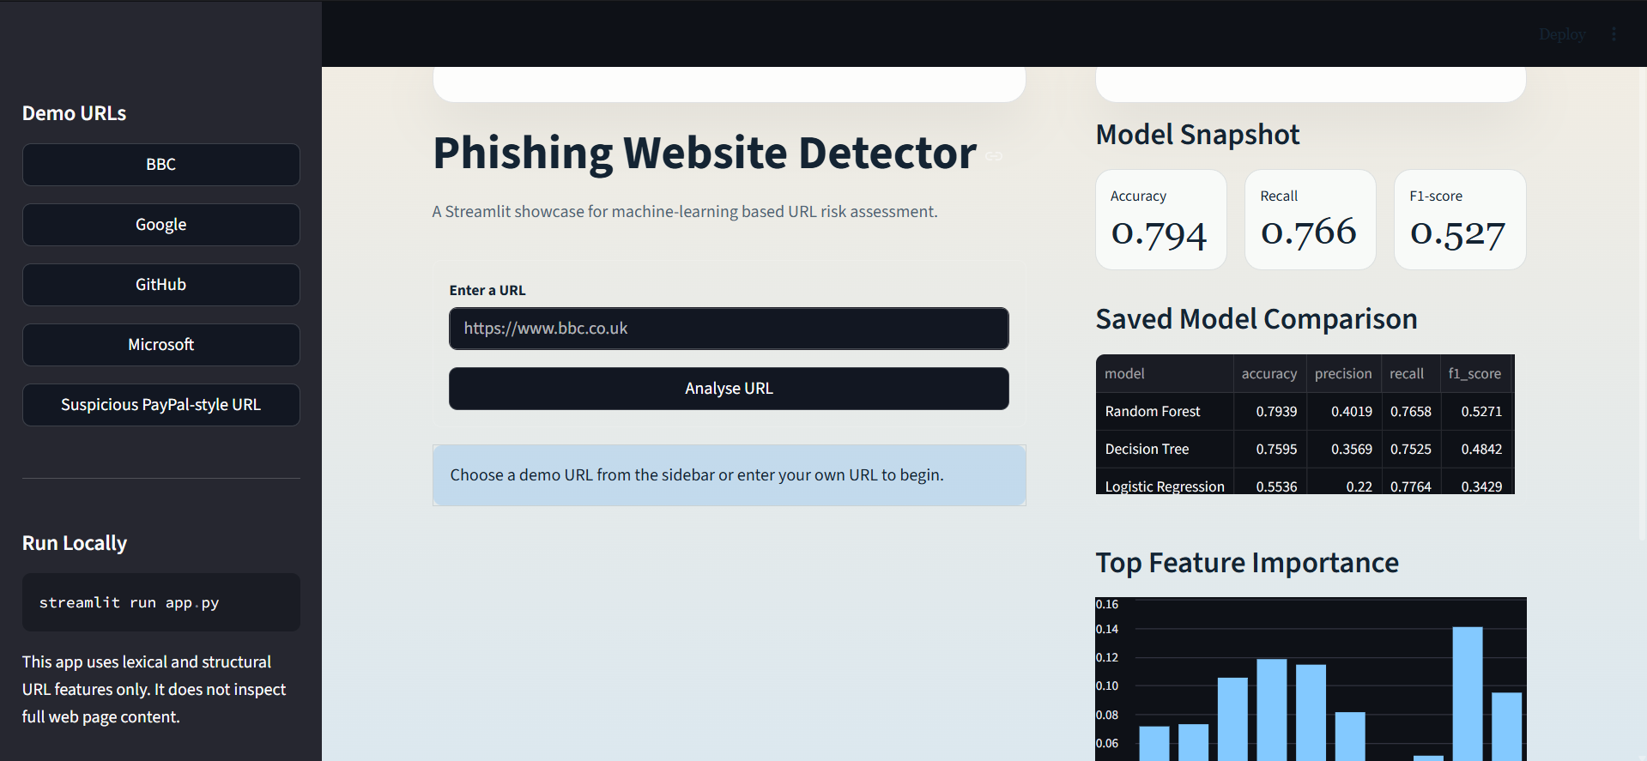
Figure 4.1: Streamlit application interface

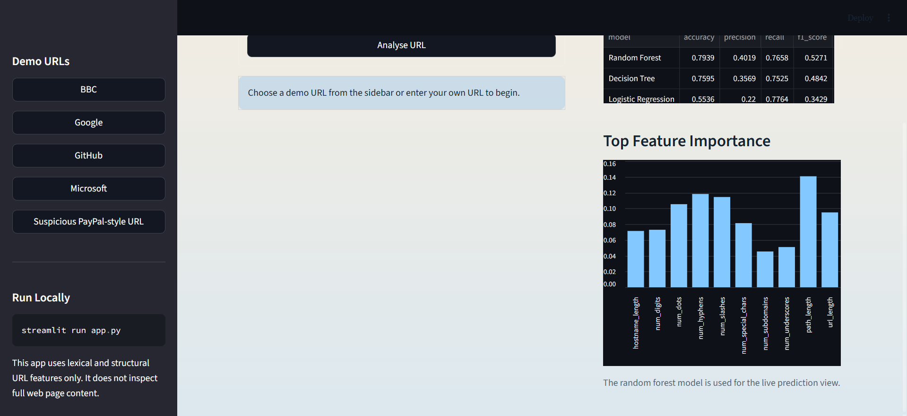

Figure 4.2 Continued: Streamlit application interface

4.11. Chapter Summary
This chapter detailed the development of the phishing detection tool, covering its modular architecture, the end-to-end machine learning pipeline, and the final Streamlit interface. By decoupling the ingestion, training, and prediction stages, the system remains both reproducible and ready for practical demonstration. The following chapter evaluates the system's performance and analyses the results generated by the final model.

5.0. Results and Analysis

5.1. Introduction
This chapter analyses the performance of the three candidate models – Logistic Regression, Decision Tree, and Random Forest – using a standardised dataset and evaluation framework. Beyond simply reporting scores, it details the selection of the Random Forest model, examines feature importance, and assesses the system’s real-world utility through manual benchmarks and the Streamlit implementation. Given the high stakes of misclassification and the inherent imbalance of phishing data, this analysis interprets the results through multiple lenses to ensure the system is both statistically sound and practically reliable (El Aassal et al., 2020; Hannousse and Yahiouche, 2021).

5.2. Performance Comparison of Candidate Models
The three candidate models exhibited distinct performance profiles. Random Forest proved the most robust, yielding 79.39% accuracy and a 0.8698 ROC-AUC. While Logistic Regression achieved the highest recall at 77.64%, its poor precision (22.00%) and accuracy (55.36%) indicated a significant tendency toward false positives. Decision Tree occupied the middle ground but trailed Random Forest across most metrics. In conclusion, Random Forest was selected for the final implementation as it offered the most reliable balance between successfully flagging phishing attempts and maintaining overall classification accuracy.

Model | Accuracy | Precision | Recall | F1-score | ROC-AUC
Random Forest | 0.7939 | 0.4019 | 0.7658 | 0.5271 | 0.8698
Decision Tree | 0.7595 | 0.3569 | 0.7525 | 0.4842 | 0.8411
Logistic Regression | 0.5536 | 0.2200 | 0.7764 | 0.3429 | 0.7233
Table 5.1 Performance comparison of candidate models

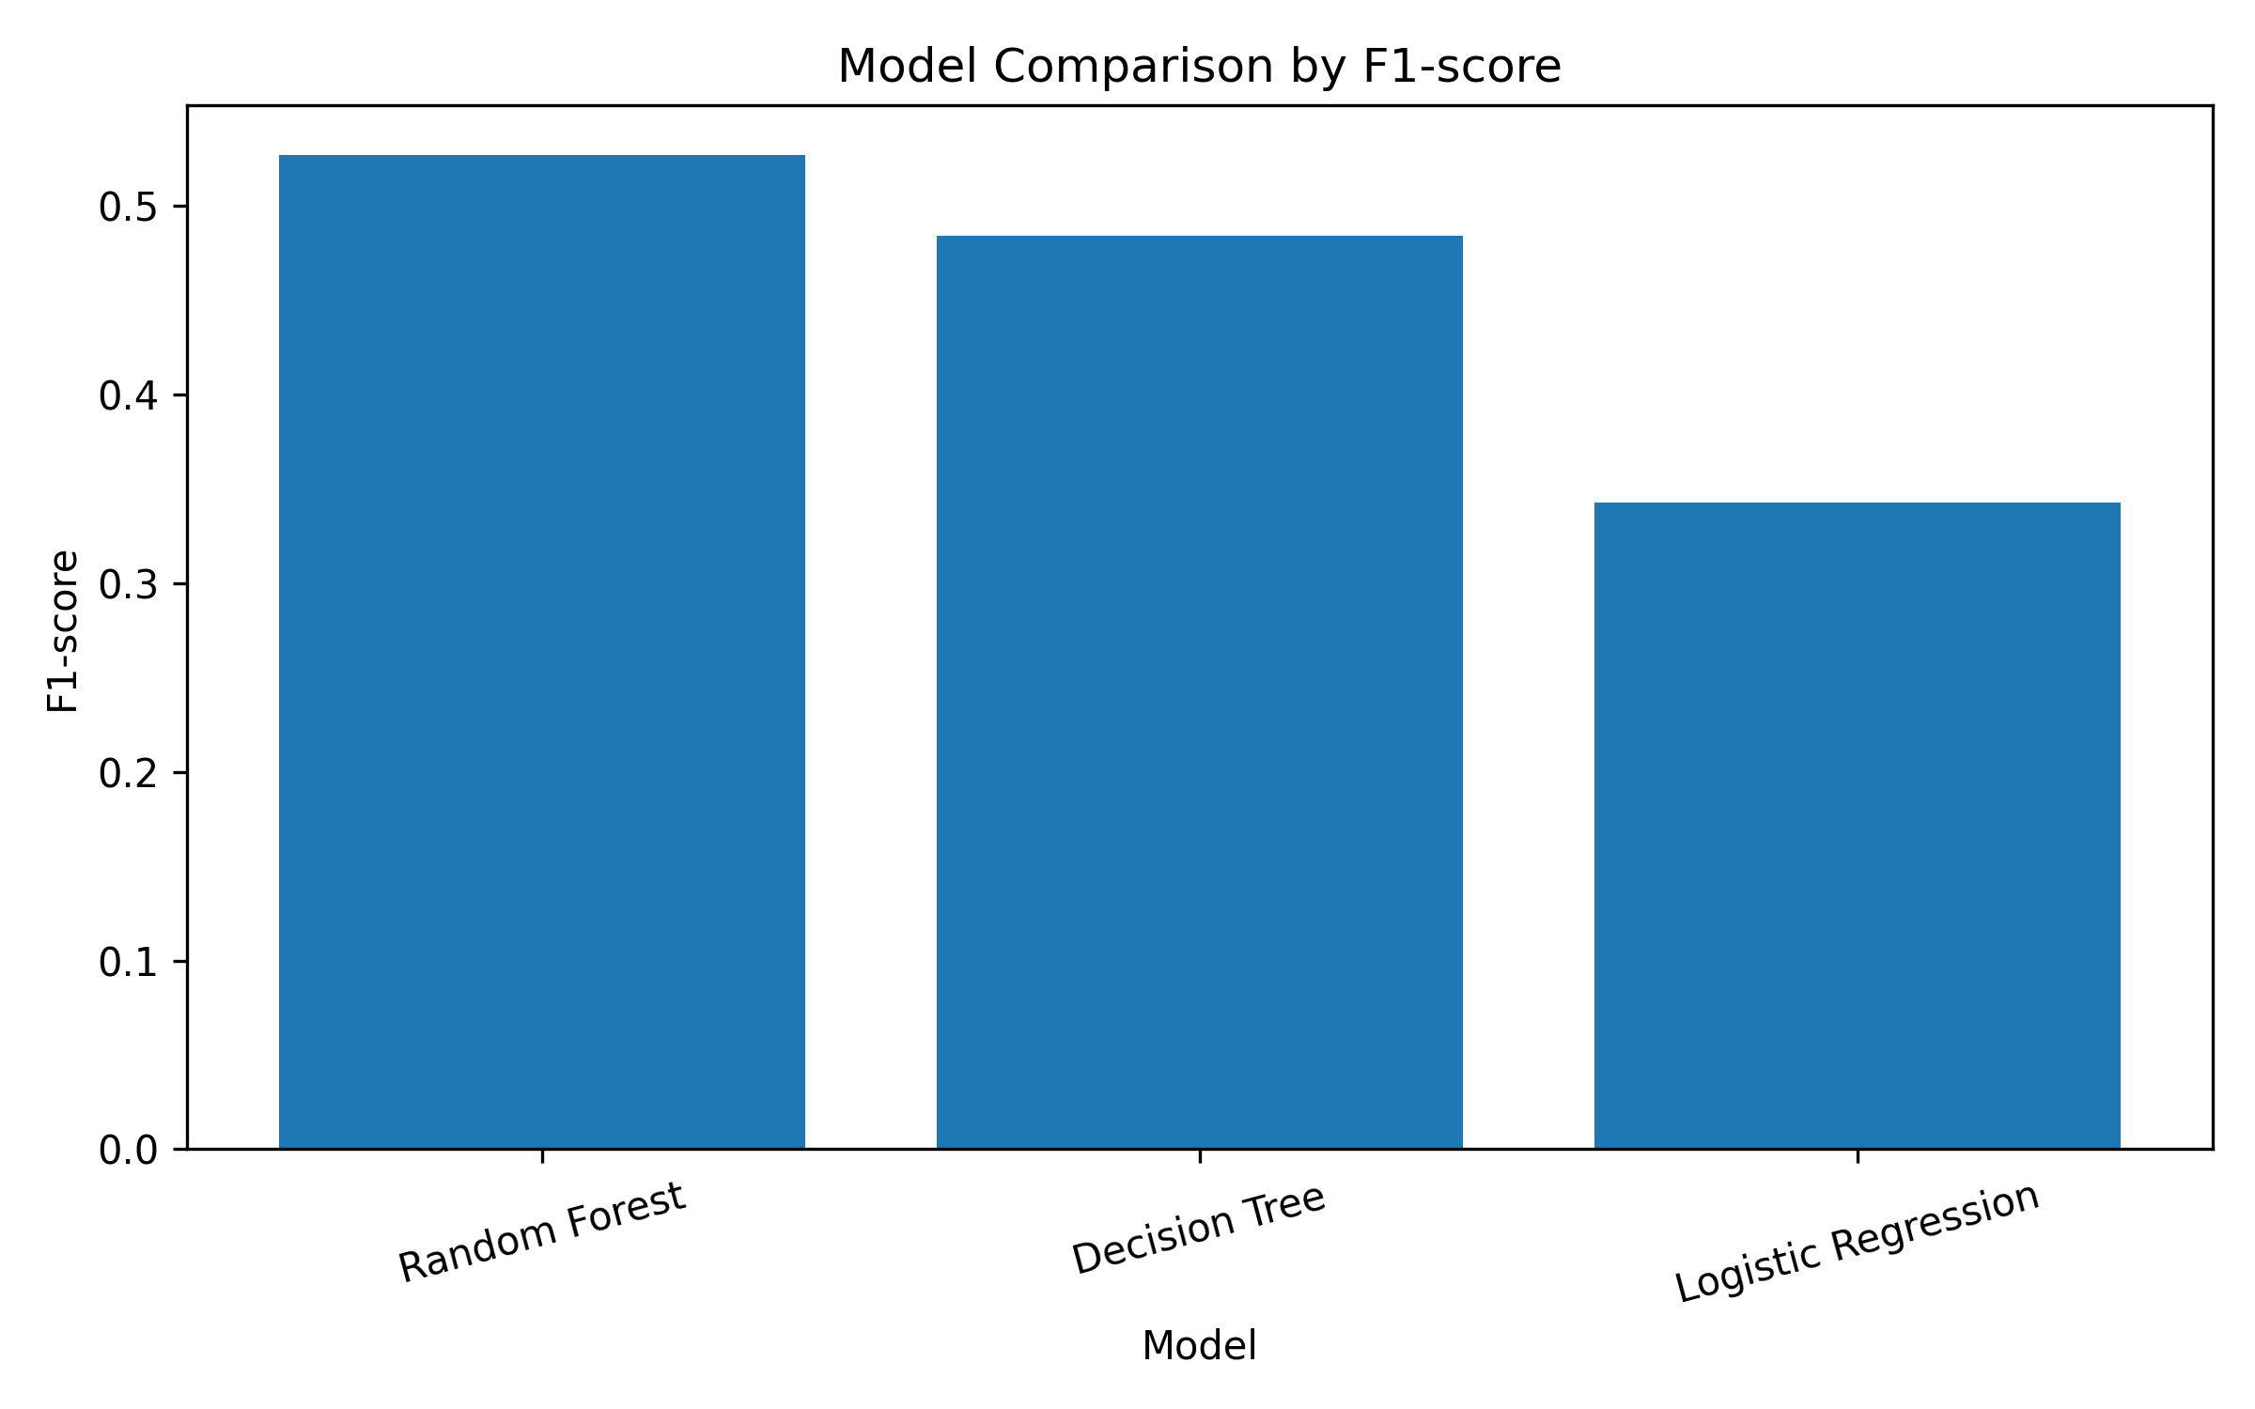
Figure 5.1: F1-score comparison of candidate models

5.2.1. Performance Breakdown
While Random Forest led in overall accuracy, the dataset’s imbalance necessitated a closer look at precision and recall. Random Forest successfully identified 76.58% of phishing attempts (recall), yet its 40.19% precision indicates a tendency toward false positives. Essentially, the model is highly effective at capturing threats but remains prone to flagging borderline legitimate URLs as suspicious. This trade-off suggests that while the system is a strong defensive net, its predictions require cautious interpretation.

5.2.2. Key Takeaways
The comparison that confirms that Random Forest offers the most effective balance for this task. While Logistic Regression served as a useful baseline, its poor accuracy and precision rendered it impractical for the final tool. The Decision Tree showed improvement but still lagged behind the Random Forest across all key metrics, including F1-score and ROC-AUC. These findings align with existing literature suggesting that ensemble methods are superior for phishing detection, as they better capture the complex feature interactions that simpler linear models or single trees often miss (Sahingoz et al., 2019; Yang et al., 2021).

5.2.3. Conclusion
Despite clear limitations in precision, Random Forest emerged as the most viable candidate. It consistently outperformed the alternatives across the evaluation suite, offering the most robust foundation for the final Streamlit application and subsequent analysis.

5.3. Selection of the Final Model
Random Forest was chosen for its optimal balance across accuracy, recall, F1-score, and ROC-AUC. While thigh recall is vital to protect users from overlooked threats, maintaining precision is equally critical for preserving system trust and avoiding “alert fatigue”. Eventually, the model serves as a practical compromise: it is highly effective at flagging risks, though its precision levels suggest further refinement would be necessary before any full-scale production deployment.

5.3.1. Balancing Detection and Reliability
The Random Forest model prioritised high recall over precision, making it effective for detection but prone to false positives. While this “better safe than sorry” bias suits an early-warning system, it lacks the surgical accuracy required for autonomous decision-making. This trade-off is a documented challenge in the field: tightening the net for phishing attempts often inadvertently capture legitimate traffic (Das et al., 2020; El Aassal et al., 2020).

5.3.2. Robustness and Discriminative Power
With a leading ROC-AUC of 0.8698, the Random Forest model demonstrated a superior ability to differentiate between classes across varying thresholds. This metric provides a more comprehensive view of model performance than simple accuracy, proving that the system successfully captured meaningful patterns. Remarkably, the model achieved this level of discrimination using only URL-derived features, without relying on webpage content, live domain data, or external reputation services.

5.3.3. A Pragmatic Choice
Random Forest was a pragmatic choice for the final tool, outperforming the alternatives while remaining more interpretable than complex deep learning models. Its support for feature importance analysis was particularly valuable, providing clarity on which URL characteristics drove specific predictions. This algins with the project’s goal: developing a functional, transparent, detection system rather than an opaque “black-box” model.

5.4. Feature Importance Analysis
Analysing feature importance clarified which URL-derived attributes most influenced the Random Forest model’s decisions. The model relied primarily on structural and lexical markers – specifically path length, overall URL length, and the frequency of hyphens, slashes, and dots. These results validate the initial feature engineering strategy, confirming that the system successfully leveraged URL complexity to identify potential threats.

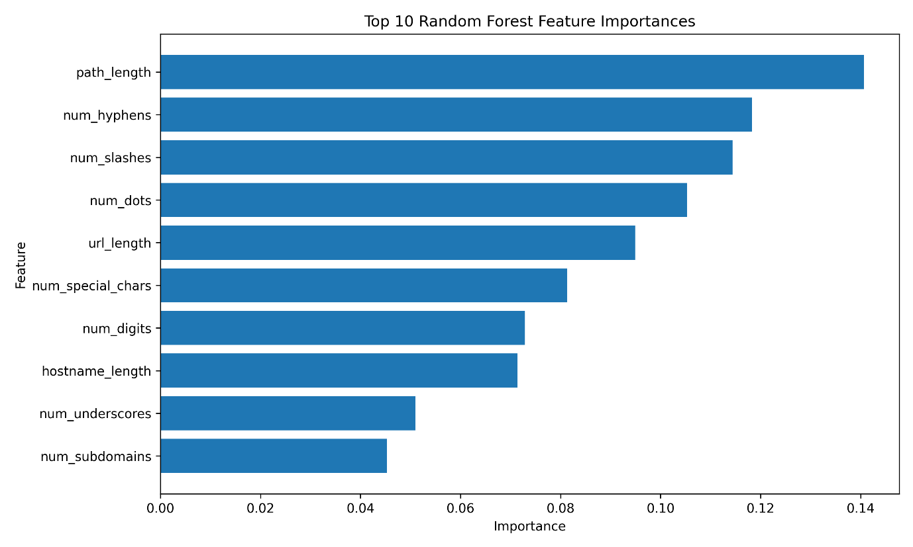
Figure 5.3: Feature importance of the final random forest model

5.4.1. Key Drivers of Prediction
Path length emerged as the most significant predictor, followed by the frequency of hyphens, slashes, dots, and total URL length. These metrics are particularly telling in a security context; attackers frequently use elongated or convoluted paths to mimic legitimate services, mask redirection logic, or bury misleading keywords within the string to deceive others.

5.4.2. Obfuscation and Structural Cues
Elements like hyphens, dots, and special characters are often used to mimic trusted brands or mask a URL’s true destination. By prioritising these attributes, the model successfully identified patterns of structural irregularity and obfuscation common in phishing. However, these markers aren’t definitive, as legitimate sites – particularly, those with complex query strings or deep directories – can exhibit similar characteristics, leading to potential misclassification.

5.4.3. Lower-Impact Features
Lower-ranked features, such as keyword and URL-shortener indicators, proved less influential than structural and length-based metrics. This likely reflects a shift in attacker tactics: many phishing links now avoid obvious “red flag” terms, while certain legitimate sites may naturally include suspicious-looking keywords. These findings underscore that phishing detection cannot rely on isolated indicators; the model’s strength lies in its ability to synthesise multiple URL characteristics into a single assessment.

5.4.4. Summary
The feature importance data confirms that the model relies primarily on structural and lexical patterns. While this validates the utility of URL-derived features, it also highlights an inherent drawback: because legitimate URLs can mirror these complex structures, relying solely on string analysis inevitably increases the risk of false positives.

5.5. Manual URL Benchmark Results
To validate the model’s real-world utility, a manual benchmark was conducted using 50 URLs (25 legitimate and 25 phishing). The system achieved 92% accuracy, successfully flagging every phishing attempt while misclassifying four legitimate sites. This external test was vital; as noted by El Aassal et al. (2020), dataset performance alone can be misleading, and this benchmark provided a clearer picture of how the system handles recognisable, real-world examples.

Metric | Result
Total URLs Tested | 50
Correct predictions | 46
Manual benchmark accuracy | 92.00%
Borderline predictions | 9
False positives | 4
False negatives | 0
Legitimate URL accuracy | 84.00%
Phishing-style URL accuracy | 100.00%
Table 5.2: Manual URL Benchmark Summary

5.5.1. Performance and Accuracy
The benchmark yielded encouraging results, achieving 100% accuracy on phishing-style URLs and 84% on legitimate sites. While the model proved highly effective at catching suspicious patterns, it remained prone to misclassifying certain legitimate pages. Although the 92% overall accuracy outperformed the initial test set, this figure should be viewed with caution given the smaller, manually curated nature of the benchmark.

5.5.2. False Positives and Limitations
The four false positives involved high-profile domains – including Amazon, Paypal, Barclays, and a Wikipedia entry on phishing. This indicates the model may be over-sensitive to brand names, security-related keywords, or structural traits that mimic suspicious links. Such errors are critical; if a system frequently flags legitimate traffic, it risks “alert fatigue”, which erodes user trust and causes people to ignore genuine warnings.

5.5.3. Summary of Findings
The manual benchmark confirmed that while the model excels at catching obvious phishing attempts, it still falters with certain legitimate URLs. These results suggest that URL-based machine learning is an effective first line of defence, but it lacks the precision to serve as a standalone security solution.

5.6. Error Analysis
The Random Forest confusion matrix – comprising 85,168 true negatives, 21,449 false positives, 4,408 false negatives, and 14,410 true positives – highlights a significant trade-off. While the model successfully caught a high volume of phishing attempts, the substantial number of false positives explains its lower precision. Both error types present distinct challenges: false negatives leave users vulnerable to undetected threats, while excessive false positives compromise usability and undermine trust in the system.
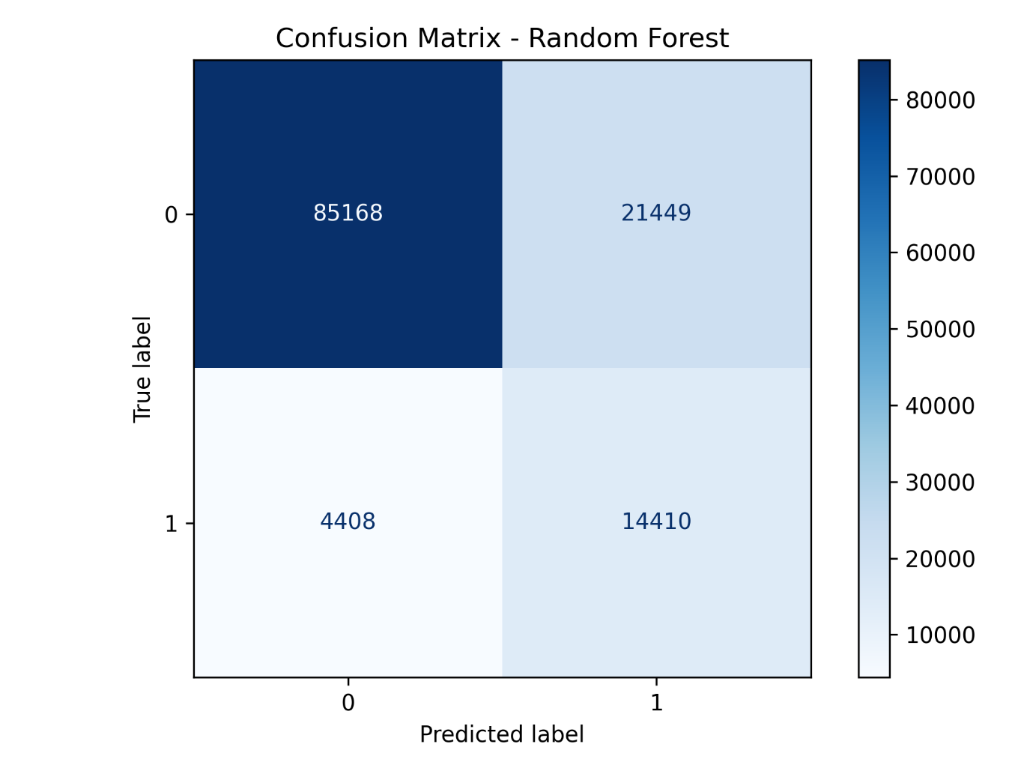
Figure 5.2: Confusion Matrix for Final Random Forest Model

5.7. Streamlit Artefact Demonstration
The Streamlit application successfully transitioned the project from a theoretical experiment to a functional tool. Through an intuitive interface, users can input a URL to receive a classification, probability score, risk level, and a breakdown of the extracted features. By also providing model comparisons and feature importance data, the application offers transparency into the decision-making process, making the results both accessible and actionable.

5.7.1. Functional Reliability and Consistency
By utilising the exact same feature extraction and prediction logic as the same training pipeline, the application ensures complete consistency between development and deployment. This makes the tool a direct implementation of the final trained system, rather than a disconnected prototype, guaranteeing that live performance mirrors the project’s experimental results.

5.7.2. Transparency and Interpretation
The application promotes transparency by moving beyond binary labels, providing users with probability scores, risk levels, and specific feature breakdowns. This approach addresses a critical need for explainability in cyber security (Ribeiro et al., 2016; Rjoub et al., 2023), ensuring that users can evaluate the evidence behind an alert rather than being forced to trust an opaque “black-box” decision.

5.7.3. Designed for Demonstration
The application was designed as a clear, practical demonstration of the project’s outcomes. By allowing users to quickly test both legitimate and suspicious URLs while displaying the underlying model data, it bridges the gap between the machine learning workflow and real-world application. This setup makes it an effective tool for showcasing the final system and illustrating exactly how the model arrives at its predictions.

5.7.4. A Realistic Presentation of Results
Rather than presenting the model as infallible, the Streamlit app uses probabilities and risk levels to communicate the inherent uncertainty in its predictions. Given the known potential for false positives and negatives, this approach provides a more transparent and responsible user experience, acknowledging the model’s limitations in a real-world context.

5.7.5. Summary
The Streamlit application provided an accessible, hands-on way to engage with the final model. By enabling users to test URLs and inspect the underlying feature data, the tool highlighted both the technical execution and the practical utility of the project. Fundamentally, this transformed the system from a backend experiment into a functional, user-facing asset.

5.8. Discussion of Findings
The findings confirm that URL-based machine learning is a viable tool for detecting phishing, particularly when links exhibit obvious structural or lexical red flags. Random Forest emerged as the most effective model, with path length, punctuation, and character counts serving as the most significant predictors.
However, the high rate of false positives highlights a clear limitation: many legitimate URLs naturally mimic these “suspicious” patterns. This underscores the necessity of a multifaceted approach; as noted by Das et al. (2020) and others, effective detection requires refined feature engineering and a practical understanding of dataset biases rather than relying on URL strings alone.

5.9. Chapter Summary
This chapter detailed the performance and analysis of the detection system, identifying Random Forest as the optimal model due to its superior balance of accuracy, recall, and ROC-AUC. While feature analysis confirmed that the system effectively leverages URL structure and lexical complexity, the manual benchmark highlighted a tendency toward false positives on legitimate domains. Decisively, these results position the system as a valuable first-stage filter rather than a comprehensive standalone defence. The following chapter will evaluate these findings against the original research questions and outline project limitations and future improvements.

6.0. Discussion and Conclusion

6.1. Introduction
This chapter evaluates the project’s findings against the research questions established in my project proposal, as well as in Chapter 1. It reflects on the system’s overall effectiveness, the utility of the resulting artefact, and the inherent limitations of the methodology. By synthesising technical results with existing literature, the discussion assesses the viability of URL-based machine learning for phishing detection and identifies key areas for future development.

6.2. Answering the Research Questions
This section addresses the research questions established in the initial project proposal and Chapter 1. The following conclusions are drawn directly from evidence detailed in Chapter 5, including the model’s performance metrics, feature importance analysis, the manual benchmark and the evaluation of the Streamlit application.

6.2.1. Research Question 1: Model Performance
The first research question examined the accuracy of machine learning when relying strictly on URL-based and lightweight metadata features.
The results indicate that these features are effective for initial detection; the final Random Forest model achieved a 79.39% test accuracy and a 0.8698 ROC-AUC, while the manual benchmark reached 92% accuracy, successfully flagging every phishing-style examples. These figures demonstrate that URL structures provide strong detection signals when clear lexical patterns are present. However, the model’s moderate precision and susceptibility false positives confirm that URL-based evidence is not a silver bullet. Consistent with findings by Sahingoz et al. (2019) and El Aassal et al. (2020), this suggests that while UR features are highly useful, they should be paired with richer data sources to ensure reliable real-world performance.

6.2.2. Research Question 2: Model Comparison
The second research question aimed to identify whether linear, tree-based, or ensemble architectures offer the best balance of accuracy and reliability.
Of the models tested, Random Forest was the clear standout. Logistic Regression suffered from excessive false positives, while the single Decision Tree failed to match the Random Forest’s performance in accuracy, F1-score, and ROC-AUC. The success of the ensemble approach suggests it is better equipped to handle the complexities of the URL feature space than simple linear or single-tree models. This aligns with findings by Sahingoz et al. (2019) and Yang et al. (2021), confirming that ensemble methods are particularly effective at capturing the intricate feature relationships common in phishing detection.

6.2.3. Research Question 3: Feature Influence
The third research question focused on how the selection of data points – specifically URL structure and lightweight indicators – impacted system performance and speed.
Feature importance analysis revealed that the model’s decisions were primarily driven by lexical complexity, specifically path length, overall URL length, and the frequency of hyphens, slashes, and dots. This lightweight feature set enabled near-instant predictions, as the system avoided the overhead of scanning webpage content or querying external metadata services. While this design prioritised speed, interpretability, and ease of reproduction, it introduced a clear trade-off: by ignoring broader context, the model occasionally struggled to distinguish between complex legitimate URLs and actual phishing threats. Ultimately, the choice of features maximised efficiency but limited the depth of evidence available for high-stakes classification.

6.2.4. Response to the Research Questions
While the research questions were answered affirmatively, the results come with significant caveats. The project confirms that machine learning – specifically the Random Forest model – effectively leverages URL structure for phishing detection. However, the findings also clarity that this system is best suited as a preliminary filter rather than a comprehensive, standalone security solution.

6.3. Main Contributions of the Project
The primary contribution of this project is the development of an end-to-end phishing detection workflow, spanning dataset preparation and feature extraction to model deployment via a Streamlit application. A key technical outcome was the comparative analysis of Logistic Regression, Decision Tree, and Random Forest architectures, which identified Random Forest as the superior model for this use case.
Furthermore, the project provides transparency through feature importance analysis and manual benchmarking. These methods moved beyond standard metrics to show exactly which URL characteristics influenced the system and how it handled specific, manually selected threats. Finally, the Streamlit application serves as a functional artefact, transforming the research into a practical tool. By displaying probabilities, risk levels, and feature values, the interface provides a transparent, user-centric alternative to “black-box” classification.

6.4. Limitations
A significant constraint of this project is its exclusive reliance on URL-derived features. While this ensures the system remains lightweight, it ignores critical external data such as webpage content, SSL certificates, and domain age – omissions that inevitably limit detection depth.
This narrow focus contributed to a notable false positive rate. The Random Forest model flagged over 20,000 legitimate URLs during testing and incorrectly identified major sites like Amazon and PayPal during the manual benchmark. These errors highlight how easily legitimate site structures can be misinterpreted as malicious when context is missing.
Furthermore, the project is subject to the standard challenges of dataset decay. Phishing tactics evolve rapidly, and a model trained on static Kaggle data may struggle to generalise to new, sophisticated campaigns. Finally, the Streamlit application should be viewed as a proof-of-concept rather than a production-ready tool, as it lacks the live threat intelligence and browser integration required for a comprehensive security solution.

6.5. Future Work
Future iterations could enhance detection accuracy by incorporating external metadata, such as domain age, SSL status, and WHOIS records. Adding context beyond the URL string would likely reduce false positives, as would the integration of webpage content analysis – specifically examining HTML structures, redirects, and visual branding (Jain & Gupta, 2019).
On the technical side, exploring gradient boosting or hybrid deep learning models could further boost performance. However, maintaining the current emphasis on interpretability remains vital for security applications (Rudin, 2019). To move toward a production-ready solution, the system could be expanded into a browser extension or API, featuring batch scanning capabilities and a pipeline for continuous model retraining.

6.6. Conclusion of the Thesis
This project successfully developed an interpretable phishing detection system by training and comparing Logistic Regression, Decision Tree, and Random Forest models. The Random Forest model emerged as the most effective, delivering a 79.39% accuracy and 0.8698 ROC-AUC on the test set, alongside a 92% success rate during manual benchmarking. The resulting Streamlit application provides a functional demonstration of this system, offering users clear insights into risk levels and underlying feature data.
While the results confirm that URL-based analysis is a powerful tool for identifying suspicious lexical patterns, the prevalence of false positives highlights the limitations of using URL data in isolation. The project fulfilled its objectives by delivering a working, transparent artefact that illustrates both the significant potential and the inherent constraints of lightweight machine learning in cyber security.

Appendices

Appendix A: Manual URL Benchmark Table

Table A.1: Manual URL Benchmark Summary
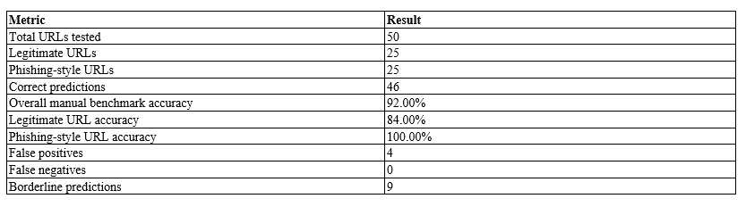

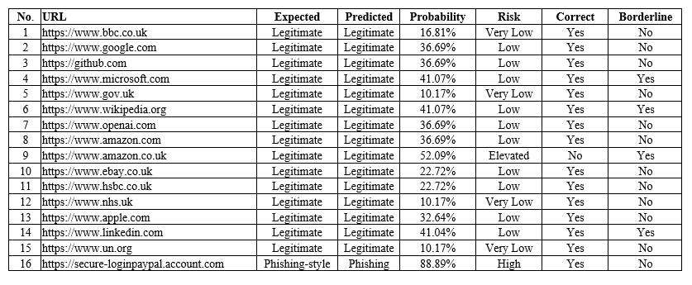
Table A.2: Full Manual URL Benchmark Results

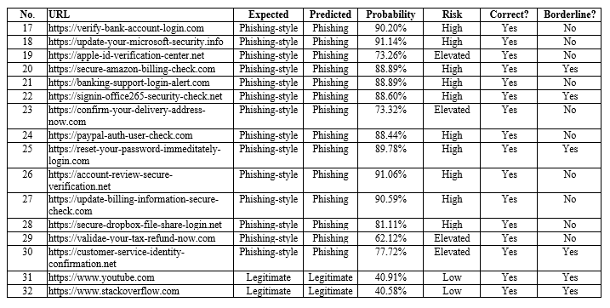
Table A.2 Continued: Full Manual URL Benchmark Results
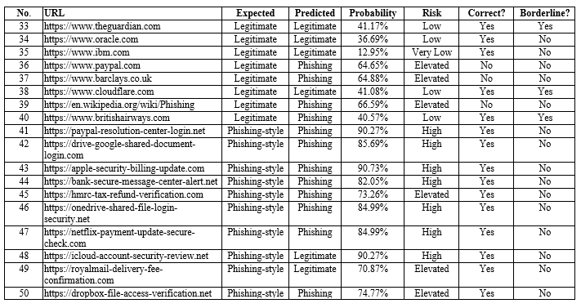
Table A.2 Continued: Full Manual URL Benchmark Results

Appendix B: Additional Figures and Screenshots

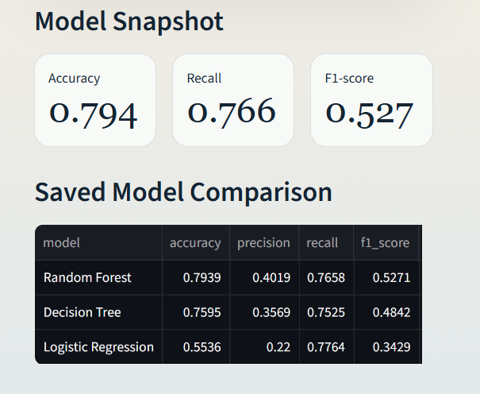
Figure B.1: Model Performance and Comparison Section

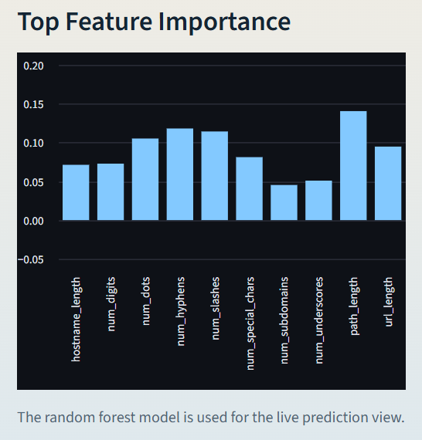
Figure B.2: Feature Importance Output in the Streamlit Application

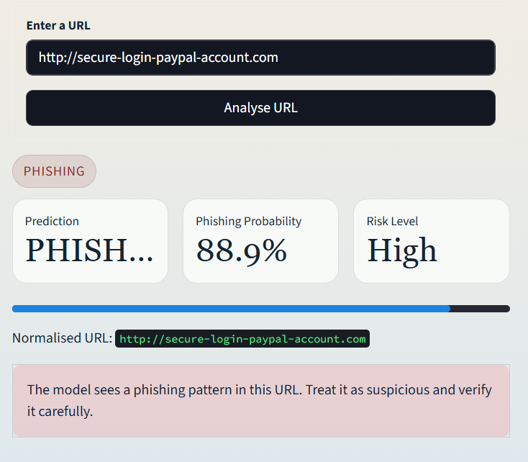
Figure B.3: Phishing-style URL Prediction Example

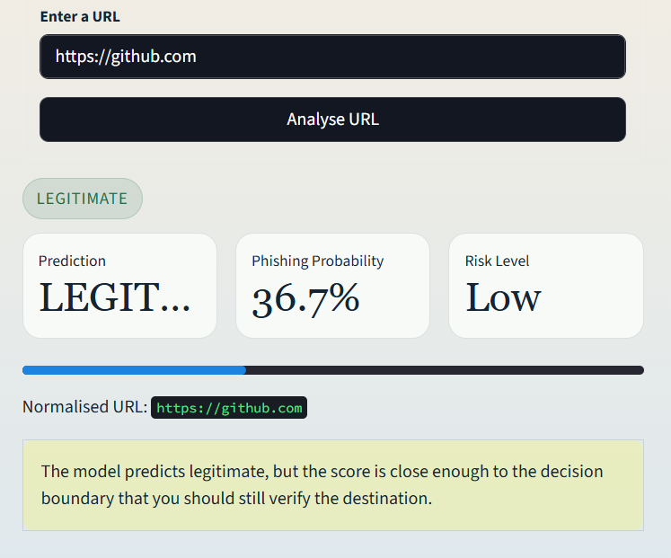
Figure B.4: Legitimate URL Prediction Example

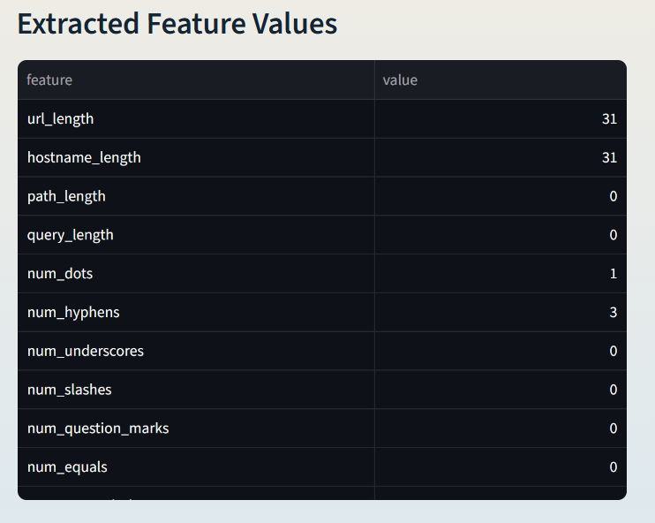
Figure B.6: Extracted URL Feature Values Displayed by the Application

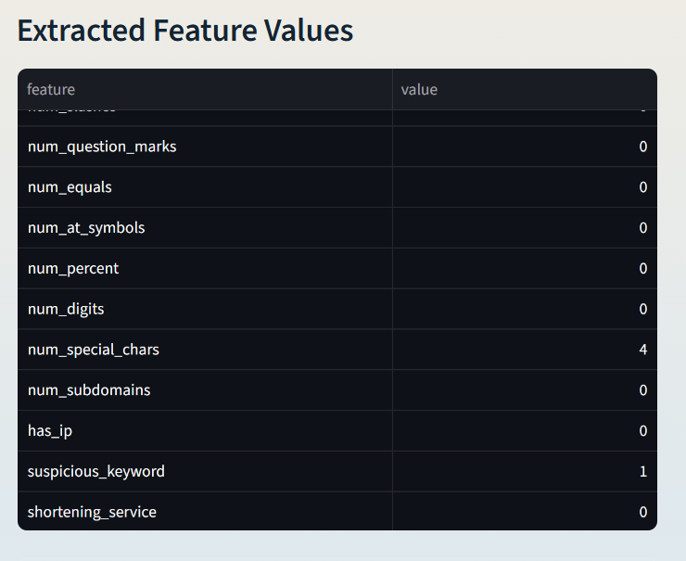
Figure B.6 (Continued): Extracted Features Values Displayed by the Application

Appendix C: Sample CLI Outputs

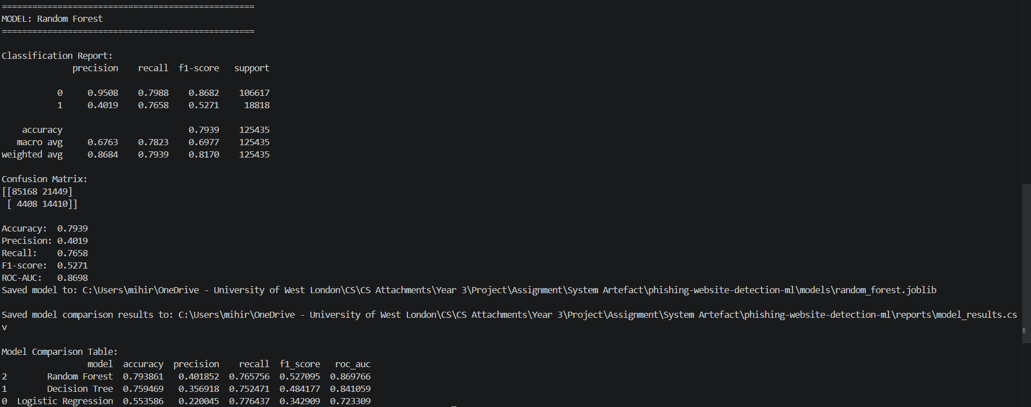
Figure C.1: Model Training Command-Line

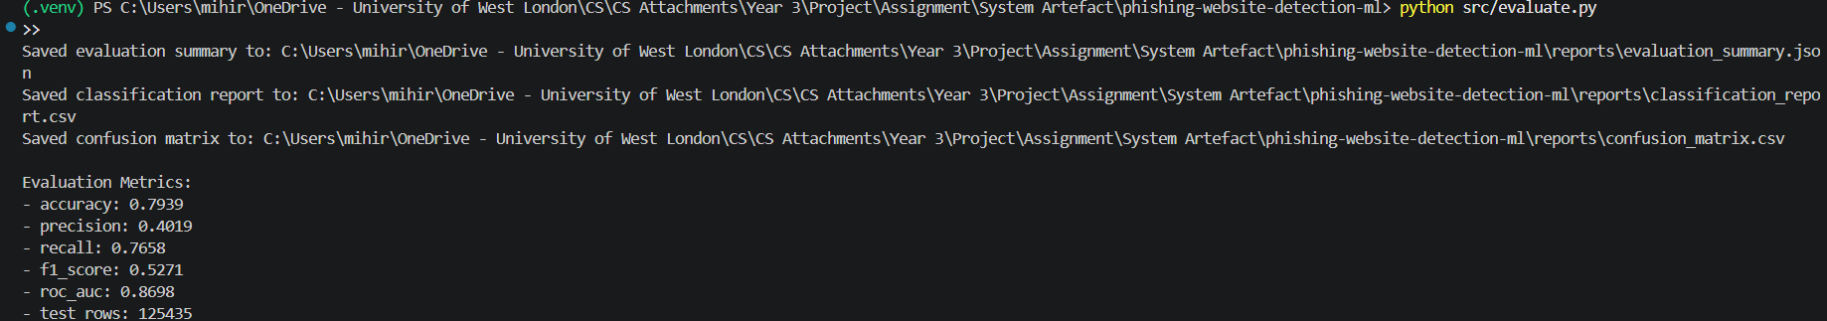
Figure C.2: Model Evaluation Command-Line Output

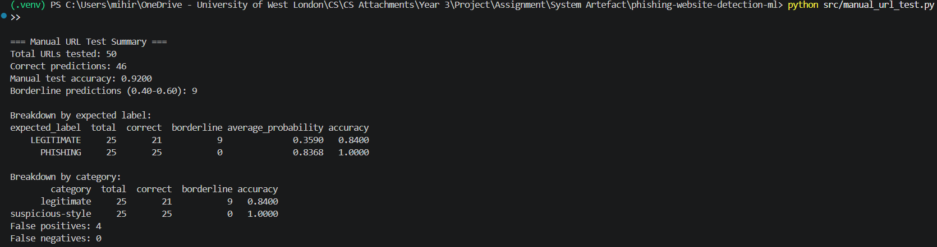
Figure C.3: Manual URL Benchmark Command-Line Output

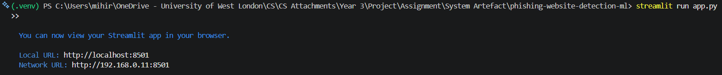
Figure C.4: Streamlit Application Launch Output

Appendix D: Live URL Prediction Workflow

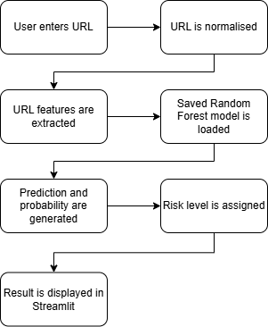
Figure D.1: Live URL Prediction Workflow

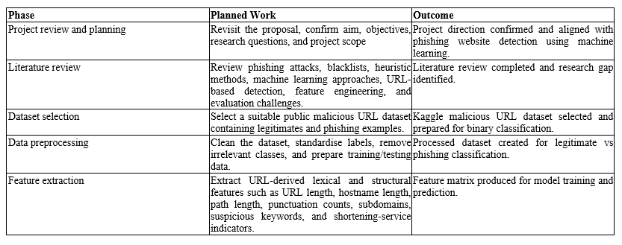
Table E.1: Project Plan Table E.1: Project Plan Appendix E: Gantt Chart/Project Plan

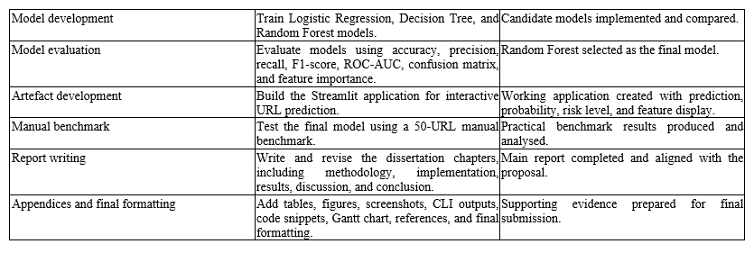
Table E.1 (Continued): Project Plan

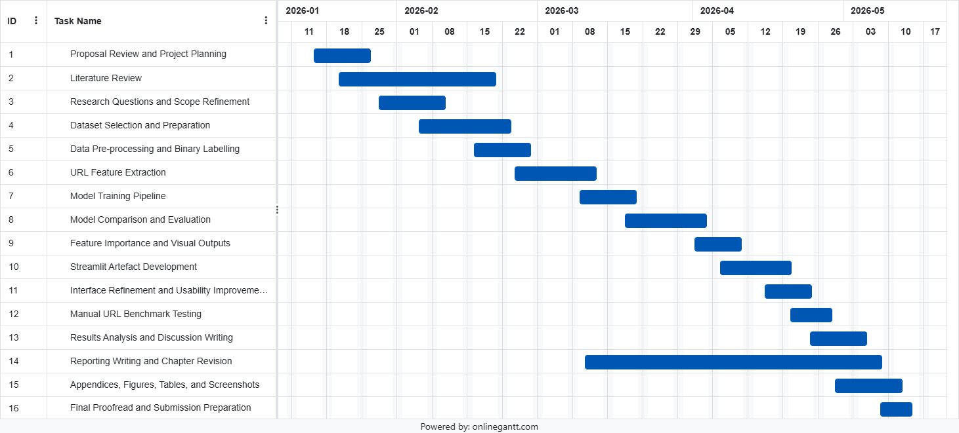
Figure E.1: Project Gantt Chart

Bibliography
Abdelhamid, N., Ayesh, A. and Thabtah, F. (2014) ‘Phishing detection based Associative Classification data mining’, Expert Systems with Applications, 41(13), pp. 5948-5959. Available at: https://doi.org/10.1016/j.eswa.2014.03.019 (Accessed: 14 October 2025).
Aburrous, M., Hossain, M.A., Dahal, K. and Thabtah, F. (2010) ‘Intelligent phishing detection system for e-banking using fuzzy data mining’, Expert Systems with Applications, 37(12), pp. 7913-7921. Available at: https://doi.org/10.1016/j.eswa.2010.04.044 (Accessed: 28 November 2025).
Al saedi, M. and Flayh, N.A. (2023) ‘Phishing website detection using machine learning: A review’, Wasit Journal for Pure Sciences, 2(2), pp. 270-281. Available at: https://doi.org/10.31185/wjps.145 (Accessed: 9 January 2026).
Anti-Phishing Working Group (APWG) (2023) Phishing activity trends reports. Available at: https://apwg.org/trendsreports (Accessed: 3 February 2026).
Anti-Phishing Working Group (APWG) (2025) Phishing Activity Trends Report, 2nd Quarter 2025. Available at: https://docs.apwg.org/reports/apwg_trends_report_q2_2025.pdf (Accessed: 17 April 2026).
Bahaghighat, M., Ghasemi, M. and Özen, F. (2023) ‘A high-accuracy phishing website detection method based on machine learning’, Journal of Information Security and Applications, 77, 103553. Available at: https://doi.org/10.1016/j.jisa.2023.103553 (Accessed: 12 December 2025).
Banik, B. and Sarma, A. (2020) ‘Lexical feature based feature selection and phishing URL classification using machine learning techniques’, in Bhattacharjee, A. et al. (eds.) Machine Learning, Image Processing, Network Security and Data Sciences. Communications in Computer and Information Science, 1241. Singapore: Springer, pp. 93-105. Available at: https://doi.org/10.1007/978-981-15-6318-8_9 (Accessed: 6 January 2026).
Chandrasekaran, M., Narayanan, K. and Upadhyaya, S. (2006) ‘Phishing email detection based on structural properties’, in Proceedings of the 9th Annual NYS Cyber Security Conference, Albany, NY, 14 June 2006. Available at: https://www.scirp.org/reference/referencespapers?referenceid=1827951 (Accessed: 25 October 2025).
Charmet, F., Tanuwidjaja, H.C., Ayoubi, S., Gimenez, P.-F., Han, Y., Jmila, H., Blanc, G. and Takahashi, T. (2022) ‘Explainable artificial intelligence for cybersecurity: a literature survey’, Annals of Telecommunications, 77, pp. 789-812. Available at: https://doi.org/10.1007/s12243-022-00926-7 (Accessed: 21 February 2026).
Das, A., Baki, S., El Aassal, A., Verma, R. and Dunbar, A. (2020) ‘SoK: A comprehensive re-examination of phishing research from the security perspective’, IEEE Communications Surveys & Tutorials, 22(1), pp. 671-708. Available at: https://doi.org/10.1109/COMST.2019.2957750 (Accessed: 18 November 2025).
Do, N.Q., Selamat, A., Krejcar, O., Herrera-Viedma, E. and Fujita, H. (2022) ‘Deep learning for phishing detection: Taxonomy, current challenges and future directions’, IEEE Access, 10, pp. 36429-36463. Available at: https://doi.org/10.1109/ACCESS.2022.3151903 (Accessed: 7 March 2026).
El Aassal, A., Baki, S., Das, A. and Verma, R.M. (2020) ‘An in-depth benchmarking and evaluation of phishing detection research for security needs’, IEEE Access, 8, pp. 22170-22192. Available at: https://doi.org/10.1109/ACCESS.2020.2969780 (Accessed: 30 January 2026).
Hannousse, A. and Yahiouche, S. (2021) ‘Towards benchmark datasets for machine learning based website phishing detection: An experimental study’, Engineering Applications of Artificial Intelligence, 104, 104347. Available at: https://doi.org/10.1016/j.engappai.2021.104347 (Accessed: 15 December 2025).
Jain, A.K. and Gupta, B.B. (2019) ‘A machine learning based approach for phishing detection using hyperlinks information’, Journal of Ambient Intelligence and Humanized Computing, 10(5), pp. 2015-2028. Available at: https://doi.org/10.1007/s12652-018-0798-z (Accessed: 11 October 2025).
Le, A., Hoang, T. and Nguyen, Q. (2018) ‘URL-based phishing detection using machine learning’, in Proceedings of the International Conference on Advanced Computing and Applications, pp. 1-6.
Ma, J., Saul, L.K., Savage, S. and Voelker, G.M. (2009) ‘Beyond blacklists: Learning to detect malicious Web sites from suspicious URLs’, in Proceedings of the 15th ACM SIGKDD International Conference on Knowledge Discovery and Data Mining. New York: ACM, pp. 1245-1254. Available at: https://doi.org/10.1145/1557019.1557153 (Accessed: 24 November 2025).
Marchal, S., Saari, K., Singh, N. and Asokan, N. (2016) ‘Know your phish: Novel techniques for detecting phishing sites and their targets’, in 2016 IEEE 36th International Conference on Distributed Computing Systems (ICDCS). New York: IEEE, pp. 323-333. Available at: https://doi.org/10.1109/ICDCS.2016.10 (Accessed: 13 March 2026).
Medvet, E., Kirda, E. and Kruegel, C. (2008) ‘Visual-similarity-based phishing detection’, in Proceedings of the 4th International Conference on Security and Privacy in Communication Networks. New York: ACM. Available at: https://doi.org/10.1145/1460877.1460905 (Accessed: 5 December 2025).
Raja, A.S., Vinodini, R. and Kavitha, A. (2021) ‘Lexical features based malicious URL detection using machine learning techniques’, Materials Today: Proceedings, 47(2), pp. 163-166. Available at: https://doi.org/10.1016/j.matpr.2021.04.041 (Accessed: 19 January 2026).
Ribeiro, M.T., Singh, S. and Guestrin, C. (2016) ‘“Why should I trust you?”: Explaining the predictions of any classifier’, in Proceedings of the 22nd ACM SIGKDD International Conference on Knowledge Discovery and Data Mining. New York: ACM, pp. 1135-1144. Available at: https://doi.org/10.1145/2939672.2939778 (Accessed: 2 April 2026).
Rjoub, G., Bentahar, J., Abdel Wahab, O., Mizouni, R., Song, A., Cohen, R., Otrok, H. and Mourad, A. (2023) ‘A survey on explainable artificial intelligence for cybersecurity’, IEEE Transactions on Network and Service Management, 20(4), pp. 5115-5140. Available at: https://doi.org/10.1109/TNSM.2023.3282740 (Accessed: 22 February 2026).
Rudin, C. (2019) ‘Stop explaining black box machine learning models for high stakes decisions and use interpretable models instead’, Nature Machine Intelligence, 1(5), pp. 206-215. Available at: https://doi.org/10.1038/s42256-019-0048-x (Accessed: 8 November 2025).
Safi, A. and Singh, S. (2023) ‘A systematic literature review on phishing website detection techniques’, Journal of King Saud University - Computer and Information Sciences, 35(8), 101610. Available at: https://doi.org/10.1016/j.jksuci.2023.01.004 (Accessed: 10 April 2026).
Sahingoz, O.K., Buber, E., Demir, O. and Diri, B. (2019) ‘Machine learning based phishing detection from URLs’, Expert Systems with Applications, 117, pp. 345-357. Available at: https://doi.org/10.1016/j.eswa.2018.09.029 (Accessed: 27 October 2025).
Shafin, S.S. (2025) ‘An explainable feature selection framework for web phishing detection with machine learning’, Data Science and Management, 8(2), pp. 127-136. Available at: https://doi.org/10.1016/j.dsm.2024.08.004 (Accessed: 16 April 2026).
Siddhartha, M. (n.d.) Malicious URLs dataset. Kaggle. Available at: https://www.kaggle.com/datasets/sid321axn/malicious-urls-dataset (Accessed: 14 February 2026).
Wenyin, L., Huang, G., Liu, X., Zhang, M. and Deng, X. (2005) ‘Detection of phishing webpages based on visual similarity’, in Proceedings of the 14th International Conference on World Wide Web. New York: ACM, pp. 1060-1061. Available at: https://doi.org/10.1145/1062745.1062868 (Accessed: 31 December 2025).
Yang, R., Zheng, K., Wu, B., Wu, C. and Wang, X. (2021) ‘Phishing website detection based on deep convolutional neural network and random forest ensemble learning’, Sensors, 21(24), 8281. Available at: https://doi.org/10.3390/s21248281 (Accessed: 26 March 2026).
Zhang, Y., Hong, J.I. and Cranor, L.F. (2007) ‘CANTINA: A content-based approach to detecting phishing web sites’, in Proceedings of the 16th International Conference on World Wide Web. New York: ACM, pp. 639-648. Available at: https://doi.org/10.1145/1242572.1242659 (Accessed: 29 January 2026).

